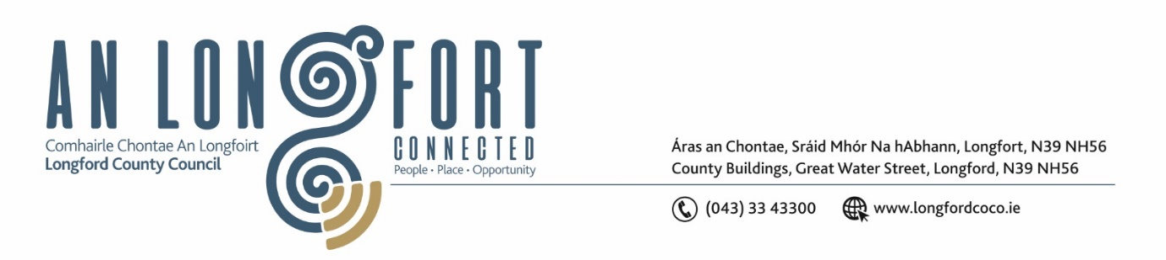
LONGFORD MUNICIPAL DISTRICT

Please note meeting will be held in the Council Chamber, Aras an Chontae and via Microsoft Teams

16 September 2026

To: Each Member of Longford Municipal District.

Dear Member,

You are requested to attend a Meeting of Longford Municipal District to be held in the Council Chamber, Aras an Chontae and via Microsoft Teams on Wednesday, 23 September 2026 at 4pm to transact business, as set out on the agenda hereunder.

Yours sincerely,
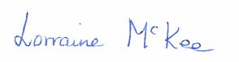
__________________________
Lorraine McKee
Meetings Administrator

AGENDA

Prayer before meeting.

1. Confirmation of Minutes:

- Longford Municipal District Meeting held on 22 July 2026 – enclosed

2. Matters arising from Minutes.

3. Declaration of Interest by Members
4. Engineers Report – enclosed
5. Correspondence from Dave Jordan, Acting District Officer, Longford CE
6. Parking Bye-laws
7. Part VIII No. 138 St. Rita’s, Park Road, Longford
8. Update on Twinning Visit
9. Update on Summer Festival
10. Notice of Motions
Councillor Seamus Butler
I call on Longford County Council that the turning on of the Christmas lights in Longford Town be brought forward to Friday 13th November this year. Furthermore, that all road and footpath works are suspended from the beginning of December in the Town central shopping district, except emergency works, until the New Year.
Councillor Uruemu Adejinmi
I call on Longford County Council to carry out junction tightening works and install a raised pedestrian crossing on the Dublin Road at the junction near the old Ardnacassa Estate & Midara Gardens in the interest of pedestrian safety.
There is currently no dropped kerb or tactile paving at this location making it difficult and unsafe for pedestrians, particularly older persons, wheelchair users, parents with buggies and those with visual impairments to cross the road safely.
I ask the Council to further examine the junction and consider any necessary interventions, including traffic calming measures, improved pedestrian crossing facilities, enhanced signage, road markings and other safety improvements deemed appropriate.
Councillor Kevin Hussey
I call on Longford County Council to carry out a speed survey and assessment of traffic speeds in the Farneyhoogan residential area, Longford, with particular attention to sections of the estate where no traffic-calming measures are currently in place, and that the Council consider the installation of additional appropriate traffic-calming measures, including speed ramps, where warranted by the findings of the assessment.
Councillor Uruemu Adejinmi & Councillor Kevin Hussey
We call on Longford County Council to develop a Smart Longford Strategy and prepare a report for the members outlining the feasibility, costs, funding opportunities and implementation options for the introduction of a countywide smart infrastructure programme incorporating:
- Solar-powered smart bins with fill-level monitoring technology;
- Free public WiFi at Council-owned buildings and strategic public locations;
- Smart environmental monitoring technologies;
- The integration of appropriate CCTV infrastructure in accordance with GDPR and all relevant legislation;
- The potential development of a pilot Smart Longford project in Longford Town and other suitable locations.
The report should identify potential funding opportunities through national and European programmes and assess the potential benefits for community safety, environmental sustainability, digital inclusion, tourism and service efficiency."

