Proposed Traffic Calming along R396 at Abbelyara Village, Abbeylara, Co. Longford

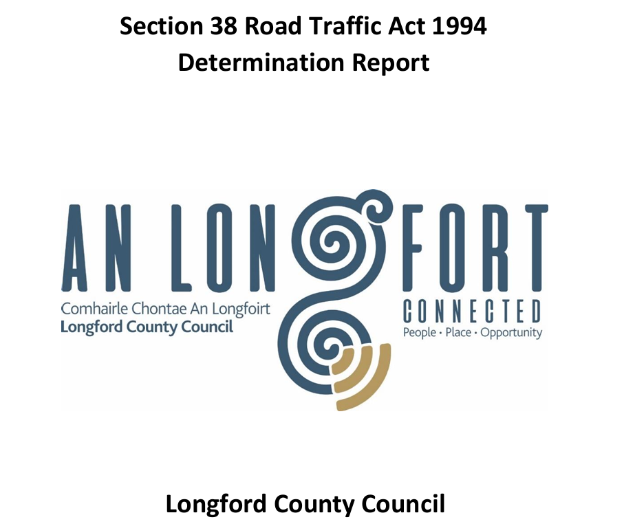

September 2026

Contents

Introduction 1
Selecting Appropriate Procedure 2
Stage 1: Is Section 38 appropriate? 2
Stage 2: EIA & AA Screening 3
EIA Screening 3
AA Screening 3
Stage 3: Planning (Applicability of Part 8) 3
Conclusion 4
Recording of this Determination 4

Introduction

The purpose of this document is to determine if the works described herein, which are proposed to be carried out by Longford County Council Roads Section, are appropriate for assessment and implementation in accordance with Section 38 of the Road Traffic Act 1994. The Department of Transport have published a guidance document on Section 38 works and it sets out types of works that can be undertaken, processes that apply for permanent works and procedures for temporary or ‘trial’ works. Such processes and procedures allow for consultation and related Traffic Works Orders (Chief Executive Orders).
It is an essential part of this process that there is a Recorded Determination of whether the works can progress under the provisions of the Section 38 procedure outline in the October 2023 Guidance Document. This is the record of that determination.

Selecting Appropriate Procedure

Stage 1: Is Section 38 appropriate?

- Identify Scope of works and assess if these constitute Traffic Calming Section 38 (9).

As part of the 2026 Community Involvement Scheme, Longford County Council intends to install traffic calming measures to improve road and pedestrian safety along the R-396 at Abbeylara Village, with the primary objective of providing traffic calming through the village, improved pedestrian access to the local facilities and improved bus stop facilities.
The proposed works involve junction tightening and reconfiguration of the roadway at the crossroads in the centre of the village to encourage a reduction in speed of vehicular traffic through the village whilst improving safety for pedestrians and vulnerable road users. The narrowing of the road at the crossroads and on both approaches will serve to reduce vehicular approach speeds which will improve safety. This will also improve the pedestrian experience crossing the road at or near the crossroads. It will also provide an opportunity to improve the bus stop facilities for the local link bus service at this location.
The proposed works, as detailed on the attached drawing (Appendix 1), include the installation of new kerbing, bus stop kerbing, footpaths, improved pedestrian crossing points, widening of existing footpaths and landscaping to improve safety and reduce speed.

On this basis it is clear that these works fall within the definition of “Traffic Calming” as outlined in Section 38 (9) of the 1994 Road Traffic Act.

- Is it all within boundaries of a public road?

Yes, all the works proposed are within the public realm area which constitutes only the roadway paved areas, and the adjacent public footpaths. All these are classified as part of the public road in accordance with Section 2 of the 1993 Roads Act.

On this basis it can be concluded that Section 38 may be appropriate unless other additional development consents or processes are required.
Stage 2: EIA & AA Screening

EIA Screening

EIA is not required as the proposed works do not fall into the classification or project thresholds requiring EIA.

In accordance with EU Directive 2011/92/EU thresholds for which an EIA is required for projects are: -

- Annex I projects (EIA required by Directive) are: -
  - “(b) Construction of motorways and express roads,
  - (c) Construction of a new road of four or more lanes, or realignment and/or widening of an existing road of two lanes or less so as to provide four or more lanes, where such new road or realigned and/or widened section of road would be 10 km or more in a continuous length.”,
- Annex II projects (Irish requirements specifying thresholds which trigger an EIA),

Includes busway (not bus lanes), service area, new 100m bridge, new 100m tunnel, four-lane road of 500m or more in an urban area and 8 km in a rural area.

Given the nature and size of this project, and its minimal impacts on the environment it can be concluded that an EIA is not required.

AA Screening

The project is located within the boundaries of Abbeylara.
The nearest Natura 2000 sites are, Derragh Bog SAC (002201) 5.4km east of the site, Ardagullion Bog SAC (002341) 7.8km south of the site and Lough Kinale and Derragh Lough SPA (004061) 5.6km east of the site.
Therefore, on the basis of the nature and scale of the development proposed, and given that there is no direct hydrological link to a Natura 2000 site, it is considered that there is no potential for significant effects on the Natura 2000 network arising from the proposed works either alone or in combination with other plans and/or projects by way of a loss fragmentation, disruption, disturbance to habitats, species or habitats of species that are of conservation interest.

Stage 3: Planning (Applicability of Part 8 Planning and Development Regulations, 2001.)

This project does not exceed the following limits,
- More than €126,000 in value.
- Construction of new or widening or realignment of an existing road greater than 100m, for Urban Area or 1km, for Rural Area
- Construction of a Bridge or tunnel
Therefore, it can be concluded that the works do not require a Part 8 process in accordance with the Planning and Development Regulations, 2001.

Conclusion

It can therefore be concluded that the proposed works fall within the scope of Section 38 and no other additional development consents or processes are required.
Therefore, these proposals can be progress under the provisions of the Section 38 procedure outline in the Oct 2023 Guidance Document, (Included as Appendix 2).
Furthermore, in addition to the consultations outlined in the Guidance Document further consultation in accordance with Section 95 of Road Traffic Act 1961, (requirement to consult with An Garda Siochana) must take place.
As these works are to be in the form of Permanent Works, then the Standard Procedure as outlined in the Section 38 Guidance Document is the appropriate procedure.
Recording of this Determination
It is necessary to record this formal determination of the suitability of Section 38 Procedure and therefore I request that this decision should be recorded in a formal decision record and published on the local authority’s website. This allows the public to become aware that such a decision has been taken in respect of the applicable proposal.
I so recommend,
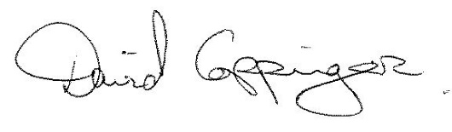

 | David Coppinger  Senior Executive Engineer  Longford County Council  Great Water St. Longford N39 NH56  ☏ 043 334 3300  ✉ dcoppinger@longfordcoco.ie  ⇒ www.longfordcoco.ie

