  3333333333333333333  APPROPRIATE ASSESSMENT  SCREENING REPORT | APPROPRIATE ASSESSMENT  SCREENING REPORT AND  CONCLUSION STATEMENT

(A) Project Details

Planning File Ref |  |  | Part 8 preparation – Lisryan Community Walkway
Applicant name |  |  | Longford County Council
Development Location |  |  | Lisryan, Co. Longford.
Site size |  |  | 2.5km long trail, 3m wide
Application accompanied by an EIS (Yes/NO) |  |  | No
Distance from nearest Natura 2000 site(s) in km |  |  | Approximately 0.5km
Description of the project/proposed development

Construction of a community walkway, c.2.5km in length, approximately 3m wide through the townlands of Lisryan and Drumman, to enhance existing laneway, new path, new bridge, fencing to accommodate both pedestrians and cyclists and ancillary works in the village of Lisryan.

(B) Identification of Natura 2000 sites which may be impacted by the proposed development
Yes/No

If answer is yes, identify list name of Natura 2000 site likely to be impacted.
1 | Impacts on sites designated for freshwater habitats or species.  Sites to consider (but not limited to): |  |  | Is the development within a Special Area of Conservation whose qualifying interests include freshwater habitats and/or species, or in the catchment (upstream or downstream) of same? | No, the project is not located within a SAC.
2 | Impacts on sites designated for wetland habitats - bogs, fens, marshes and heath.  Sites to consider (but not limited to): Ardgullion Bog SAC; Glen Lough SPA and Lough Kinale and Derragh Lough SPA. |  |  | Is the development within a Special Area of Conservation whose qualifying interests include wetland habitats (bog, marsh, fen or heath), or within 1 km of same? | The project site is not located within a SAC.  The project site is located approximately 0.5km upstream of Ardgullion Bog SAC whose qualifying interests include wetland habitats.
3 | Impacts on designated terrestrial habitats.  Sites to consider (but not limited to): Ardgullion Bog SAC |  |  | Is the development within a Special Area of Conservation whose qualifying interests include woodlands, dunes or grasslands, or within 100m of same? | The project site is not located within an SAC or 100m of same.
4 | Impacts on birds in SPAs  Sites to consider (but not limited to):  Glen Lough SPA and Lough Kinale and Derragh Lough SPA |  |  | Is the development within a Special Protection Area, or within 5 km of same? | The project site is not located within a SPA or 5km of same.
(C) Identification of Potential Impacts on Habitats and Birds
1 |  | Impacts on designated rivers, streams, lakes and freshwater dependant habitats and species  If ‘Yes’ is recorded in answer to question 1 in Table B, please answer the following.  Does the development involve any of the following:
1.1 |  | Works within the boundary of a Special Area of Conservation (SAC) excluding small extensions/alterations to existing buildings.
1.2 |  | Discharge to surface water or groundwater within 5km of SAC.
1.3 |  | Abstraction from surface water or groundwater within 5km of SAC
1.4 |  | Removal of topsoil within 500m of watercourses.
1.5 |  | Infilling or raising of ground levels within 100m of watercourses.
1.6 |  | Construction of drainage ditches within 1km of SAC.
1.7 |  | Installation of wastewater treatment systems; percolation areas; septic tanks within 500m of watercourses.
1.8 |  | Construction within a floodplain or within an area liable to flood.
1.9 |  | Crossing or culverting of rivers or streams within 5km of SAC.
1.10 |  | Storage of chemicals, hydrocarbons or organic wastes within 1km of a watercourse.
1.11 |  | Development of a large-scale which involves the production of an EIAR.
1.12 |  | Development of quarries/mines.
1.13 |  | Development of windfarms.
1.14 |  | Development of pumped hydro-electric stations.
1.15 |  | Construction of roads or other infrastructure on peat habitats within 1km of rivers, streams, lakes and freshwater-dependant habitats.
2 |  | Impacts on designated wetlands – bogs, fens, marshes and heath  If ‘Yes’ is recorded in answer to question 2 in Table B, please answer the following.  Does the development involve any of the following:
2.1 |  | Works within the boundary of a Special Area of Conservation (SAC), excluding small extensions/alterations to existing buildings. |  |  |  | No
2.2 |  | Construction of roads or other infrastructure on peat habitats within 1km of bog, marsh, fen or heath habitat within a Natura 2000 site. |  |  |  | No
2.3 |  | Development of a large scale within 1km of bog, marsh, fen or heath habitat within a Natura 2000 site which involves the production of an EIS. |  |  |  | No
3 |  | Impacts on other designated terrestrial habits (woodland, grasslands)  If ‘Yes’ is recorded in answer to question 3 in Table B, please answer the following.  Does the development involve any of the following:
3.1 |  | Works within the boundary of a Special Area of Conservation (SAC).
3.2 |  | Development within 200m of Natura 2000 site with woodland, grassland or coastal habitats.
3.3 |  | Development of a large scale within 1km of Natura 2000 site with woodland, grassland or coastal habitats which involves the production of an EIS.
4 |  | Impacts on birds in SPAs  If ‘Yes’ is recorded in answer to question 4 in Table B, please answer the following.  Does the development involve any of the following:
4.1 |  | Works within the boundary of a Special Protection Area (SPA) excluding small extensions/alterations to existing buildings.
4.2 |  | Erection of wind turbines within 5km of a SPA.
4.3 |  | Proposed discharges directly to SPA.
4.4 |  | Development of cycleways or walking routes within 100m of SPA.

Conclusion:
If the answer to all of the above is No, significant impacts on habitats within Natura 2000 sites can be ruled out.
No further assessment is required in relation to habitats.
If the answer is Yes, you will require further information, which should be provided in the form of a Natura Impact Statement which should address the particular issues of concern as identified through the above.

Consideration of potential impacts on protected species within SACs

Currently, one of our Special Areas of Conservation is designated for species as well as for habitats, namely Lough Ree SAC, which includes habitat for otters Lutra lutra. Activities could have an impact on this protect species. Please tick if you are concerned that the proposed development could have an impact on these species.

Species | Relevant Site(s) | Activities which could have impacts on species | Possible Impacts Identified Yes/No
Otter | Lough Ree | Activities that interfere with river banks. | No
Conclusion:
If the answer to all of the above is No, significant impacts on species can be ruled out.
If the answer is Yes, then further information is likely to be required in relation to potential for impact on that particular species.

(D) Summary of Impacts
Natura 2000 Sites within impact zone |  |  | Glen Lough SPA, Lough Kinale and Derragh Lough SPA
Qualifying features of Natura 2000 Site (attach site synopsis from National Parks and Wildlife Service (NPWS)) |  |  | See Site Synopsis below
(E) Assessment of Likely Significant Effects (from Tables above)
Describe how the project or plan (alone or in combination) could affect the Natura 2000 site(s).
From the tables above, it is considered the project (alone or in combination) will not affect the Natura 2000 sites.

If there are potential impacts, explain whether you consider if these are likely to be significant.
N/A

(F) Relevant Advice Received
Documentation reviewed for making this statement.
Appropriate Assessment of Plans and Projects in Ireland – Guidance for Planning Authorities (2010)
Assessment of Plans and Projects significantly affecting Natura 2000 sites (2001)
Managing Natura 2000 sites: The provisions of Article 6 of the ‘Habitats’ Directive (2018)
Relevant Site Synposis.

Persons/Bodies consulted with for the making of this statement.
Longford County Council Planning Department

(G) SCREENING CONCLUSION STATEMENT
Selected relevant category for project assessed by ticking box.
1 | AA is not required because the project is directly connected with/necessary to the conservation management of the site
2 | No potential significant affects/AA is not required |  |  | x
3 | Significant effects are certain, likely or uncertain.  Seek a Natura Impact Statement  Reject proposal. (Reject if potentially damaging/inappropriate)
Justify why it falls into relevant category above (based on information in above tables)
The proposal has no potential significant affects on the Natura 2000 network for the following reasons:
- The project site is not located within a SAC or in the catchment of same to impact on sites designated for freshwater habitats or species.
- The project site is not located within a SAC. It is located within 1km of site designated for wetland habitats. However, it does not involve construction of roads or other infrastructure on peat habitats within 1km of bog, marsh, fen or heath habitat within a Natura 2000 site.
- The project site is not located within an SAC or 100m of same to impact on designated terrestrial habitats.
- The project site is not located within a SPA or 5km of same to impact on birds in SPAs.

Name: |  | Lorraine O’Connor
Position: |  | Regeneration Officer (Executive Planner)
Date: |  | 24/03/2022

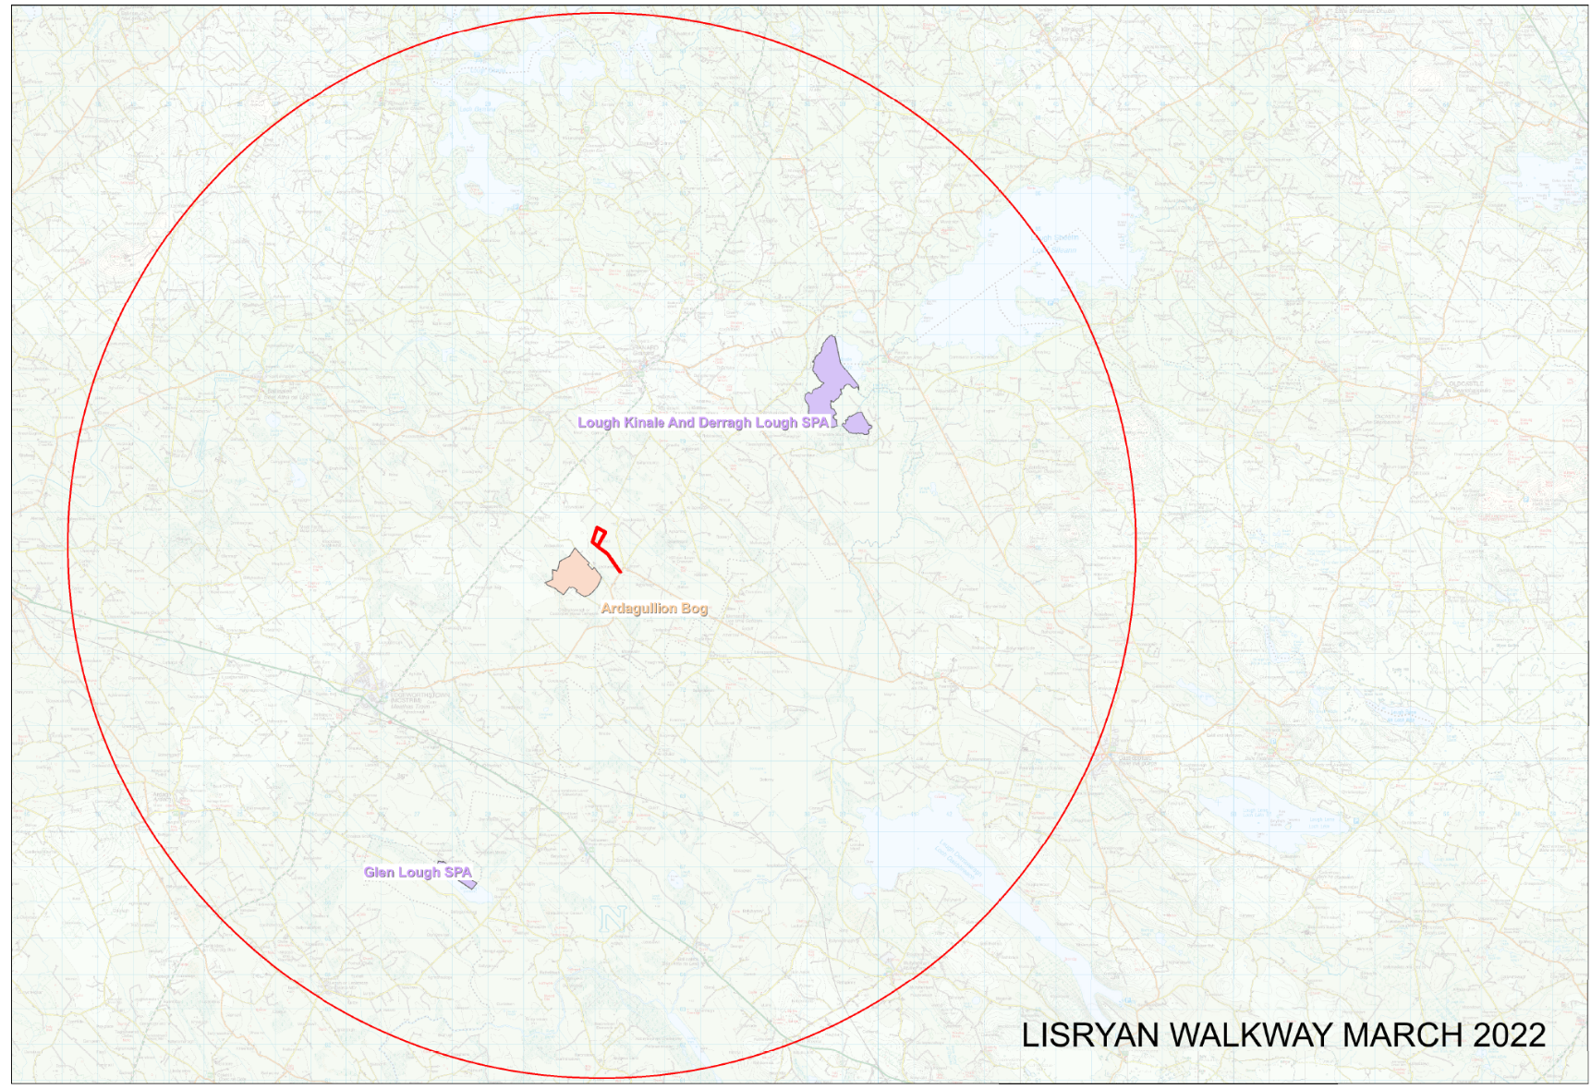

Map of proposed trail with 15km buffer zone

