Step-by-Step Registration Guide

- Go to www.mycoco.ie

- Scroll to bottom of page & under Payments, click on Register Account.
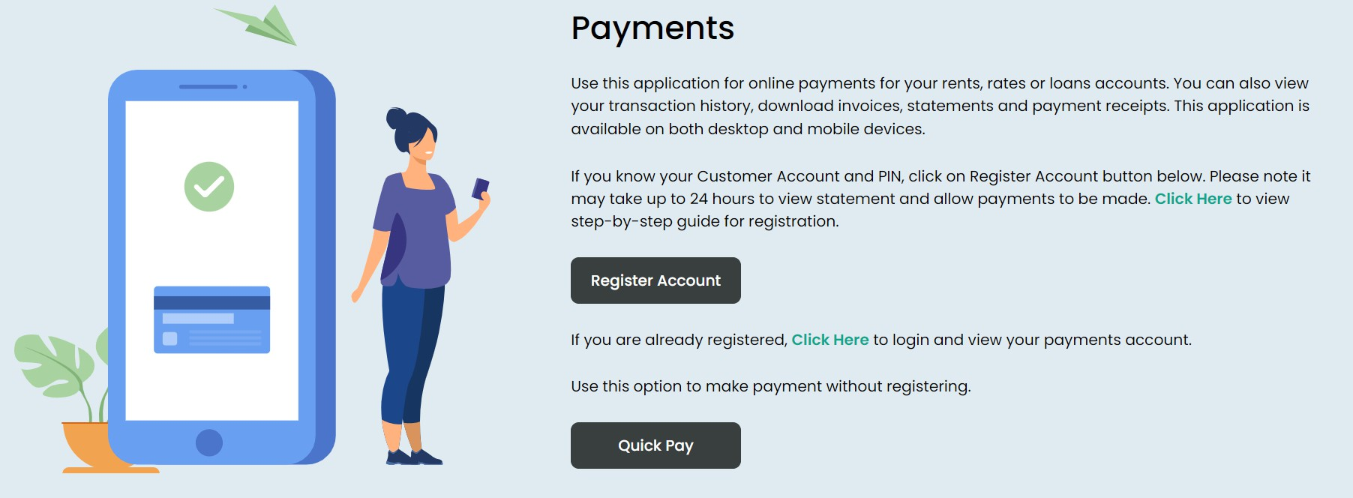

- Select Longford County Council from the dropdown list.

- Enter your Customer Number. This is the same number you use to make payments. It is also available on your statement and on the letter we sent you with your PIN . For queries regarding your Customer Number, please contact rentpaymentqueries@longfordcoco.ie or call 043 334 3414

- Enter your PIN - this was sent via letter from Longford County Council. For queries regarding your Customer Number, please contact rentpaymentqueries@longfordcoco.ie or call 043 334 3414.

- Click on NEXT.
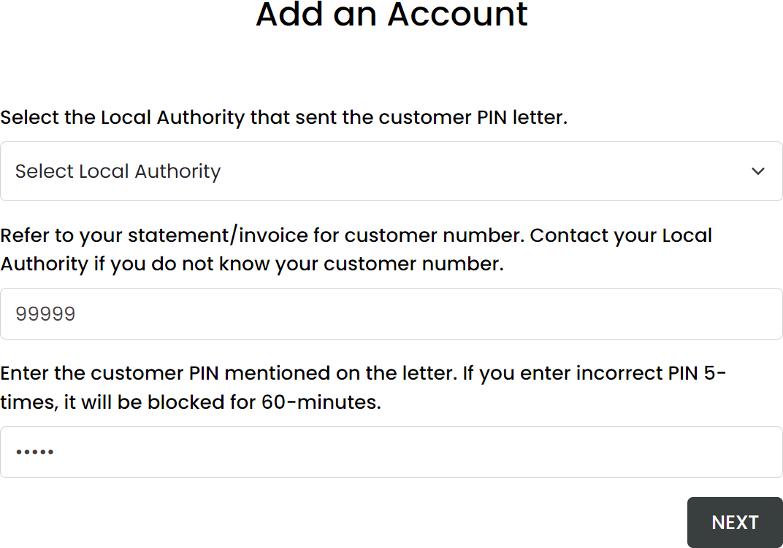

6. Enter your email address.

Please ensure you use a valid email address that you have access to. MyCoCo will send an OTP to verify this
email address. Your temporary password will also be sent to this address to complete the registration process.

This email address will be your Login ID for MyCoCo. Notifications, receipts, and other emails such as password changes will also be sent to this address. Click on NEXT.
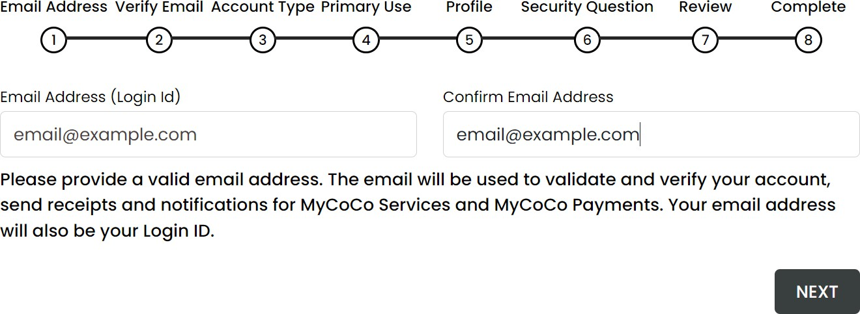

7. A One Time Passcode (OTP) will be sent to your email. This is valid for five minutes. Enter passcode into the
Verify Email Screen.
Check your spam and junk email folders if you do not see the OTP in your mailbox. You can request a new OTP after 60 seconds.
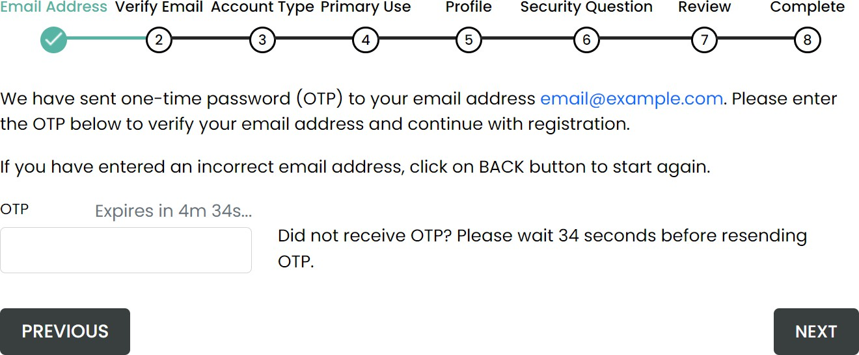

8. Once the OTP is verified, Click on NEXT to continue with the registration process.
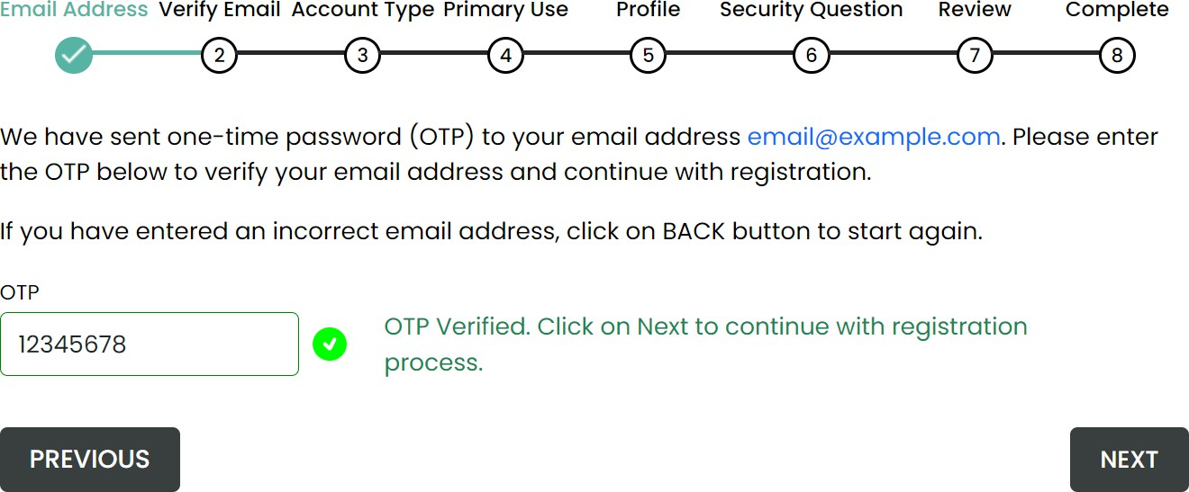

9. Complete your profile.
Please enter your name, address, and phone details. This information may be used by the Local Authority staff to confirm your identity when you contact them in relation to your account.
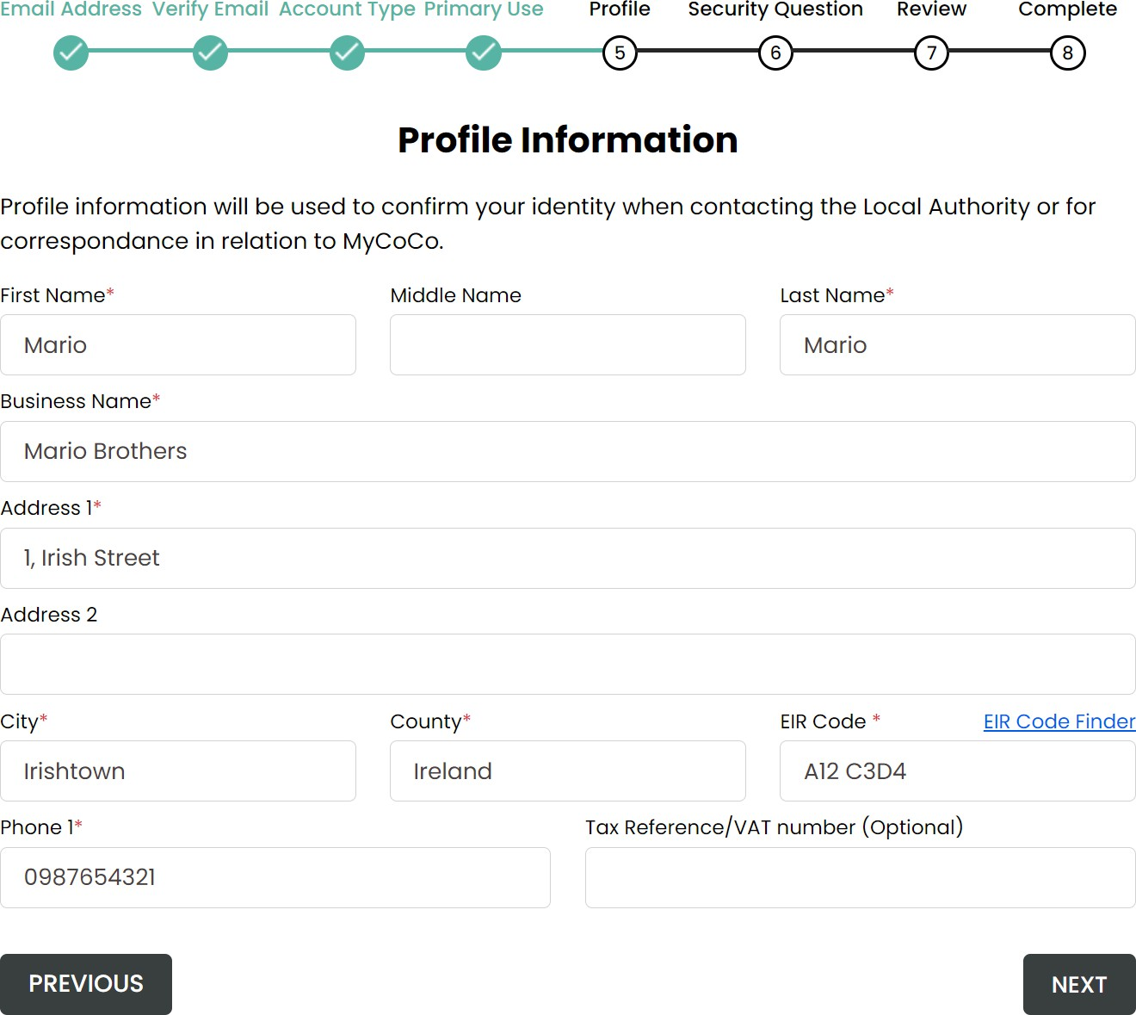

10. This is an optional step. Nonetheless, we advise that you create a security question because it will help us to confirm your identity when you query your MyCoCo account.

Click on NEXT.
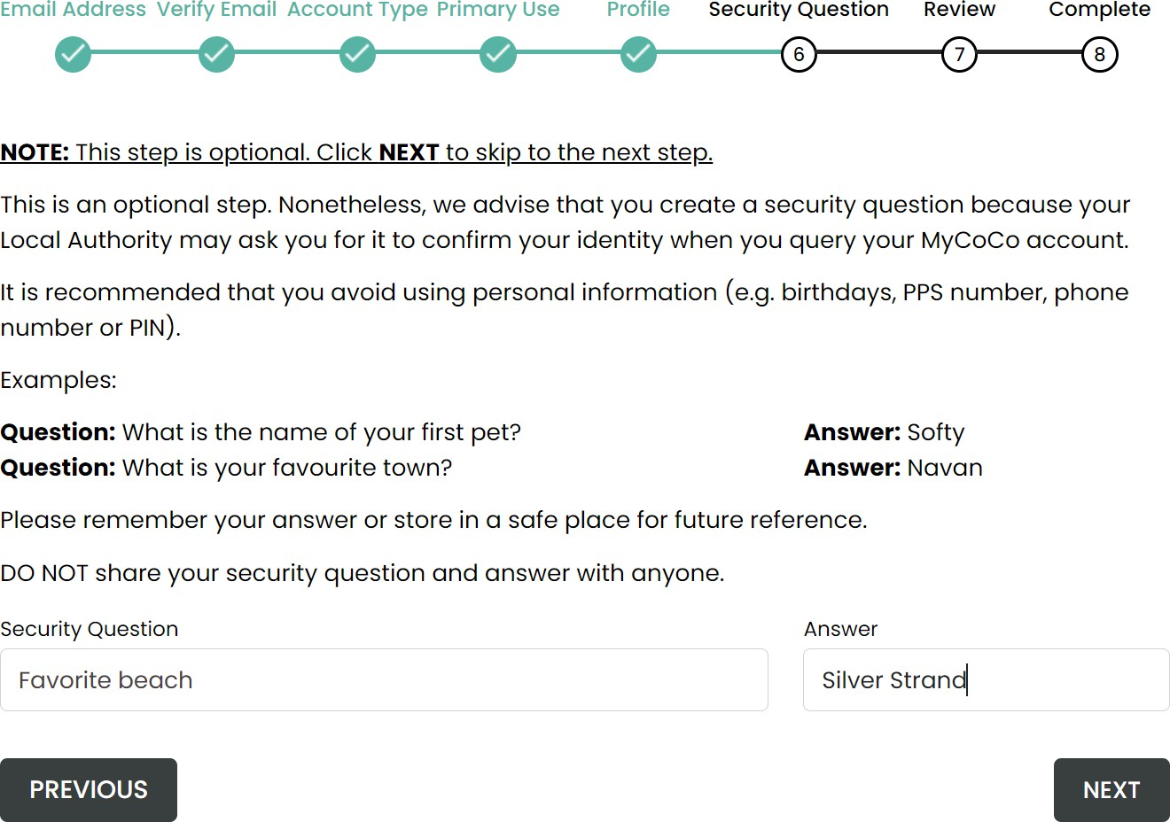

11. This is profile summary page that shows the customer number and account you are registering with your profile
details.

If the Customer Account number and Profile Information is incorrect, click on PREVIOUS to return to Profile screen to make amendments. If correct, you must read and agree to the Terms & Conditions, Data Privacy Policy and confirm that you are adding your own customer account to MyCoCo.

Click on CREATE ACCOUNT to continue registration.
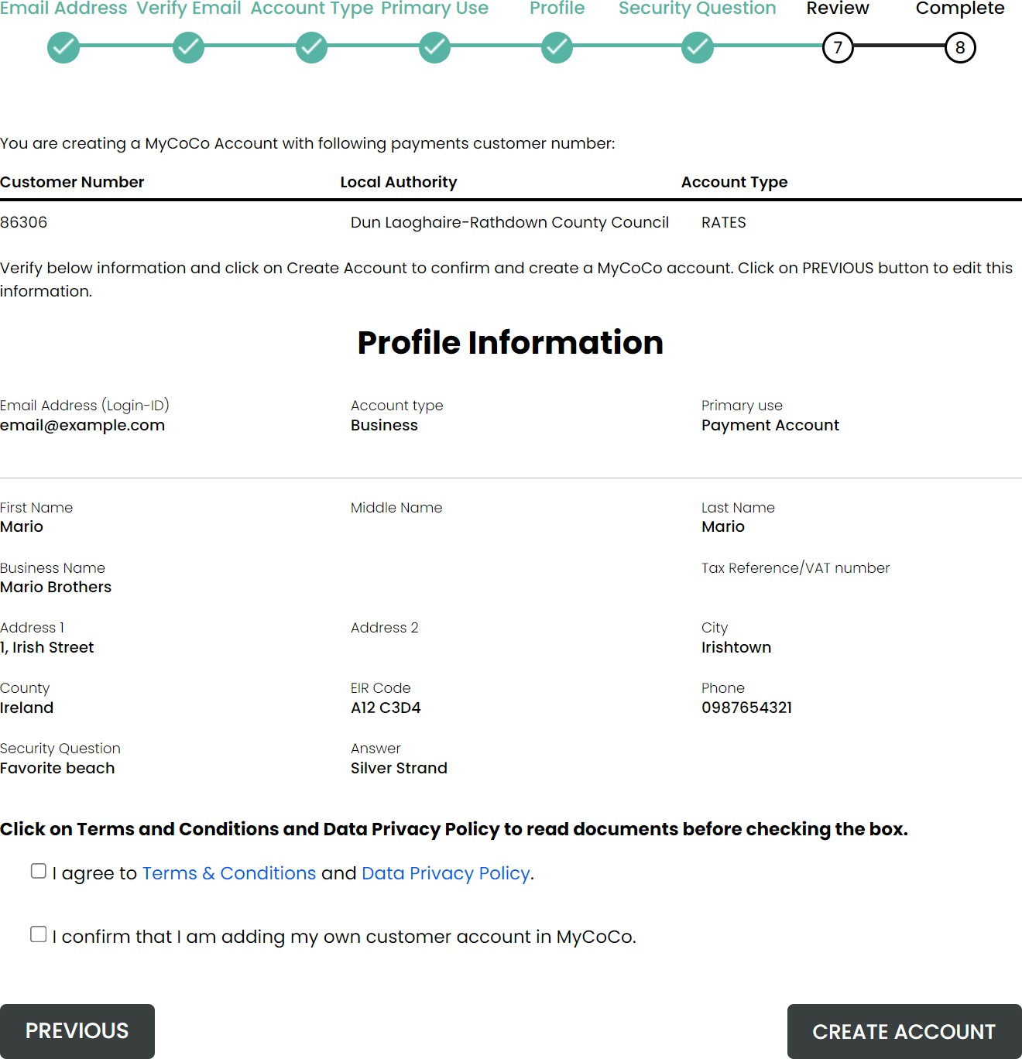

14. Your registration is now near complete.

A temporary password has now been sent to the email address that you provided in Step 6. Check your email.
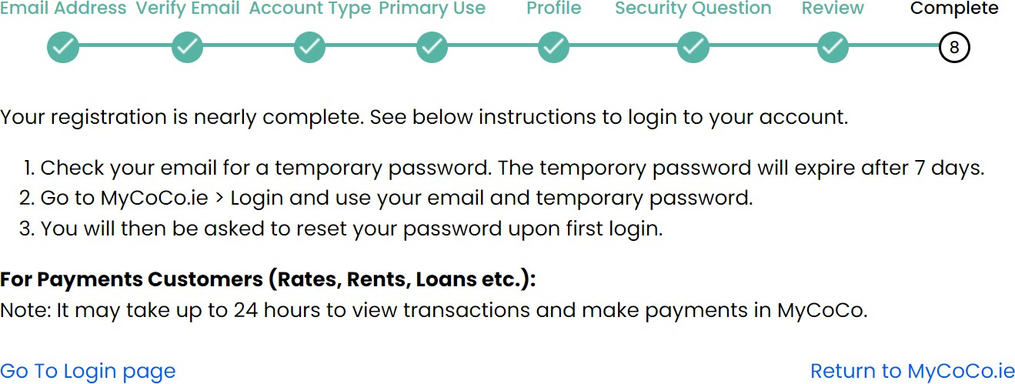

- Open the email and note or copy the temporary password. Note: Make sure to NOT copy the spaces before and
after the password.

- Click on the link provided in the email.
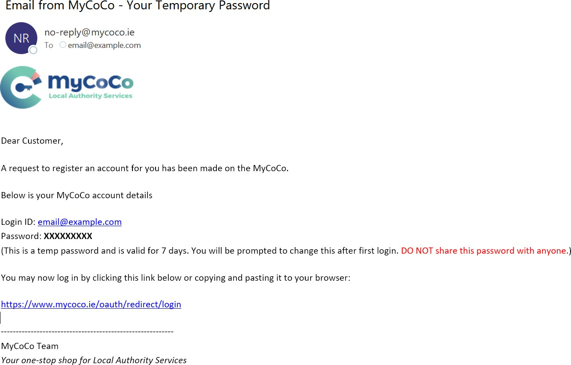

- Image 1 - Enter your email address and temporary password. Click on Next.
- Image 2 - Check your mailbox for an email with OTP (one-time password).
- Image 3 - Enter OTP.
- Image 4 - Enter new password in both fields. Please use a password with at least one upper case, one lower case, one numeral and one special character. Memorize the new password or note and store it in a safe place.
- Click on Login.
Image 1 – Login
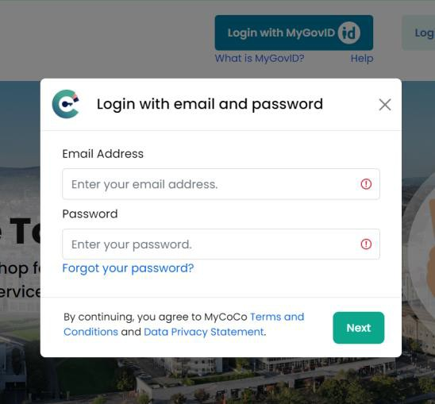
Image 2 – OTP Email | Image 3 – Enter OTP
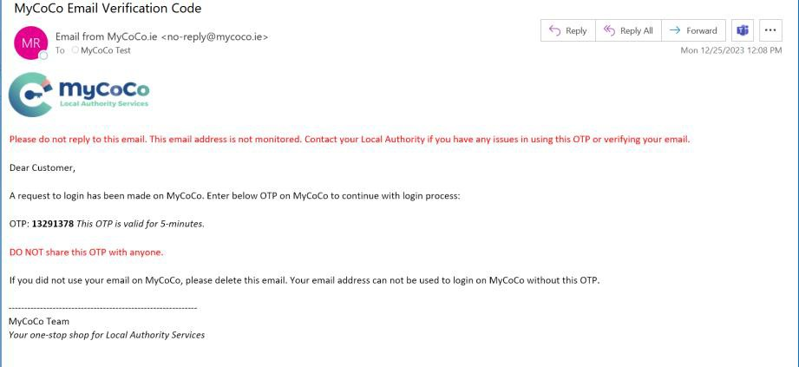 | 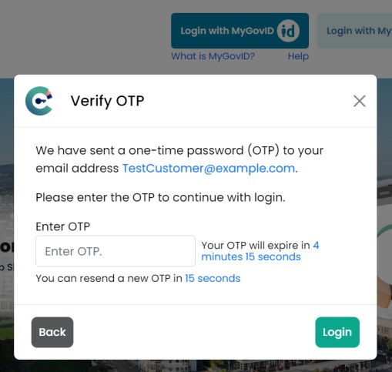
Image 4 – Change Password
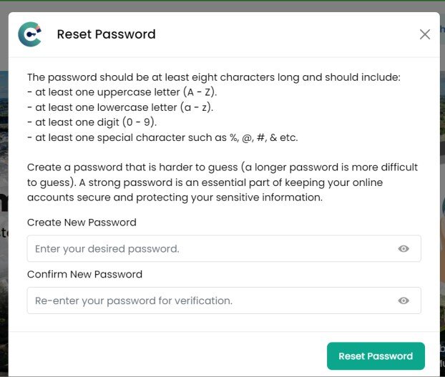

22. Congratulations. You have successfully completed the registration process and have logged-in to your MyCoCo
account.

You will also receive a Welcome To MyCoCo email.

NOTE: It may take up to 24 hours after registration for your account to sync with your Local Authority. Once synced, you will be able to view your transactions, download statements and make online payments in MyCoCo.
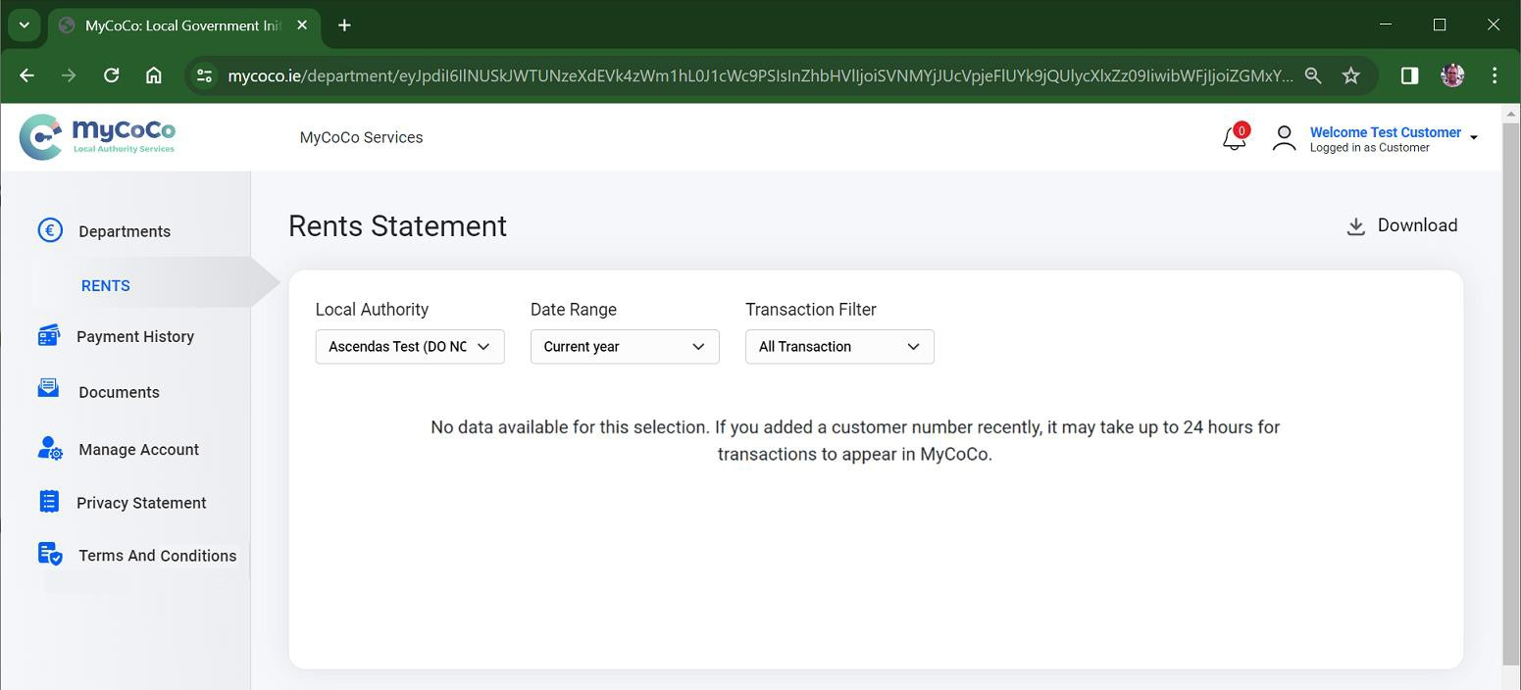
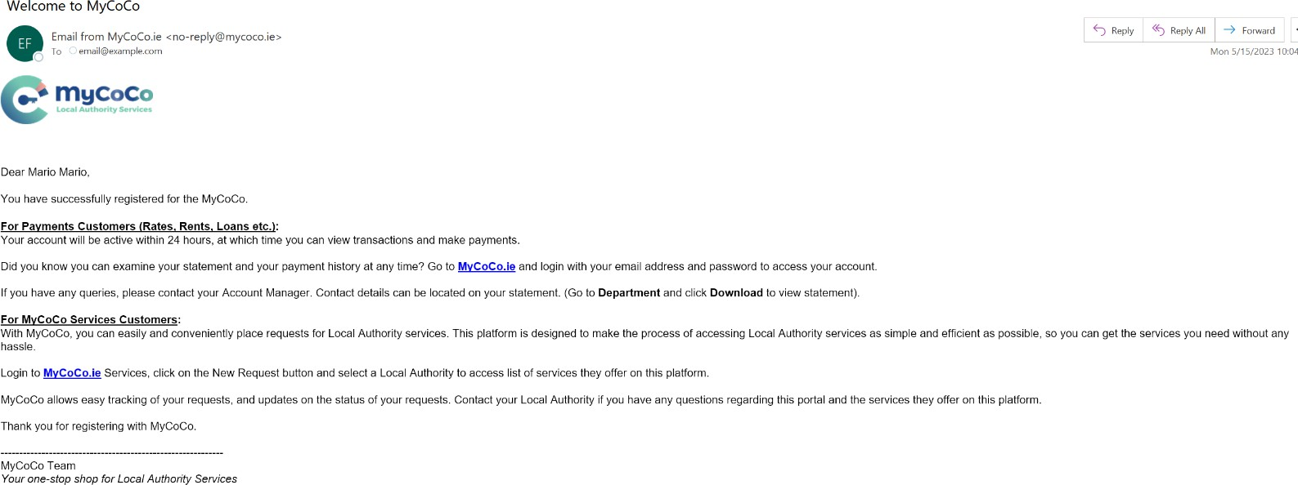

23. To login to MyCoCo again in future, go to www.mycoco.ie and click on Log in. Use your email address and the
new password to login to and access your MyCoCo account.
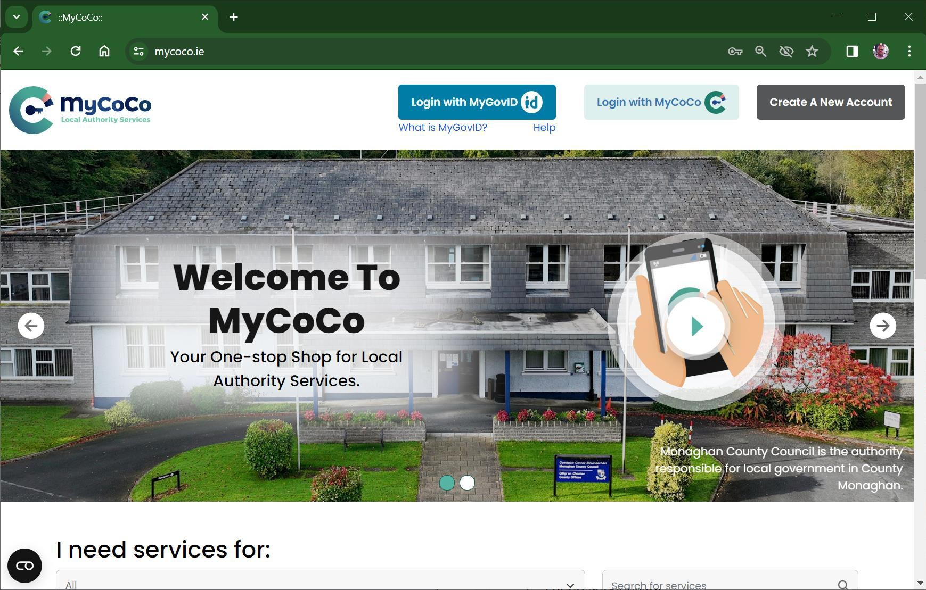

Contact your Longford County Council Rent Payment Team on 043 334 3414 for questions related to your MyCoCo account.

