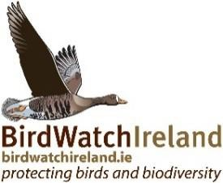
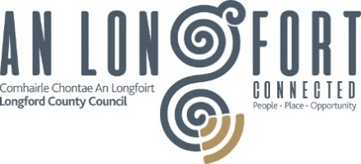
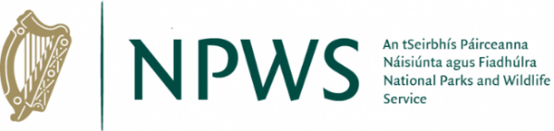

Barn Owl population status and trends in County Longford
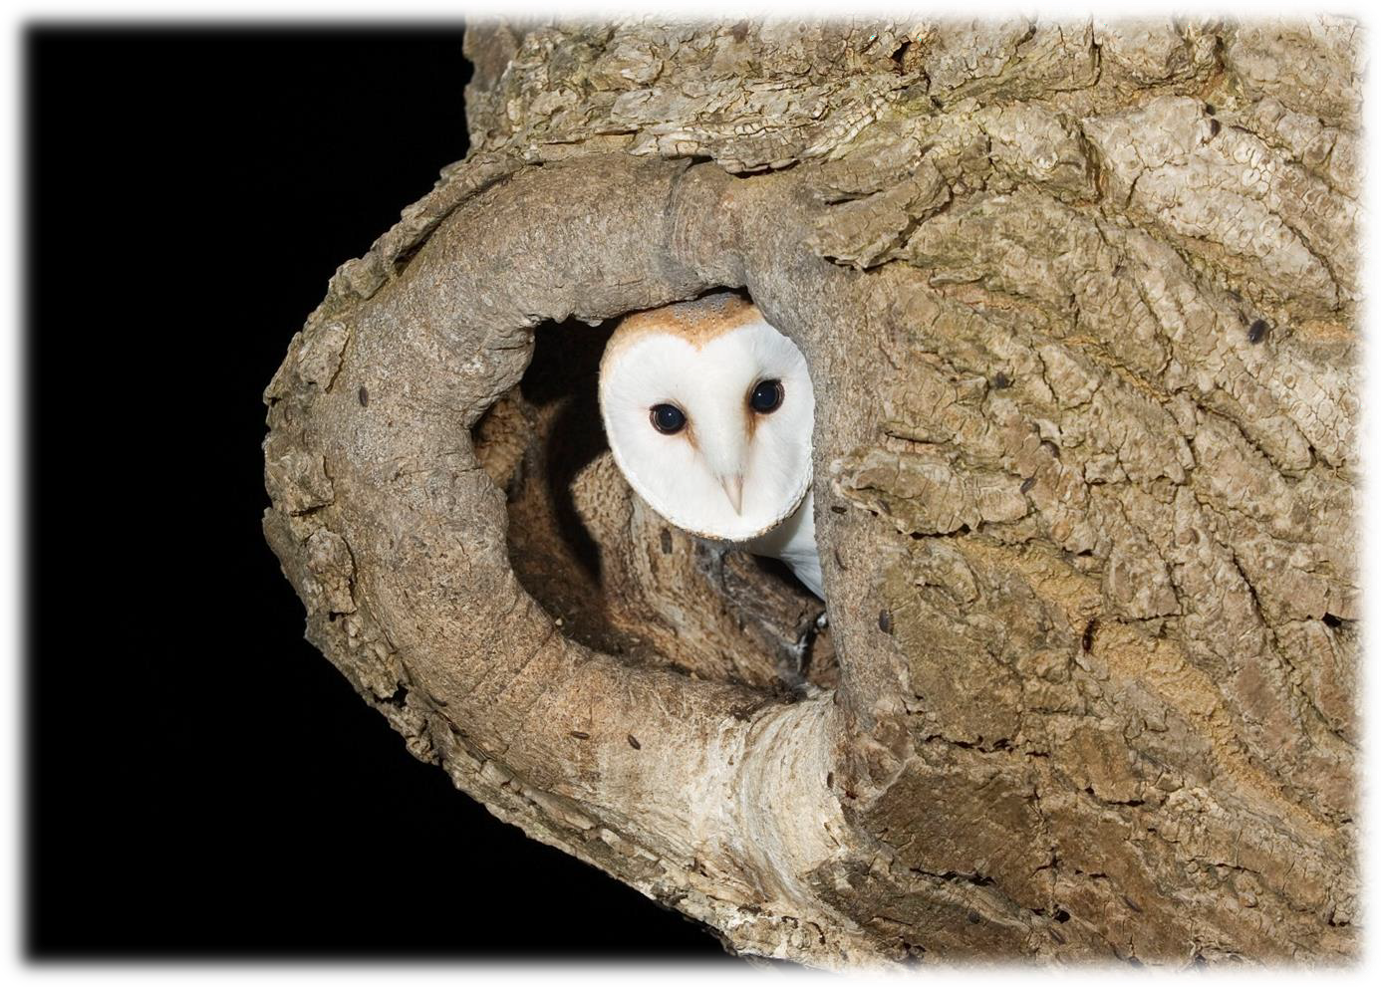

Prepared by BirdWatch Ireland for Longford County Council
October 2024

Address for correspondence: BirdWatch Ireland, Unit 20, Kilcoole, County Wicklow
Corresponding author: John Lusby, email: jlusby@birdwatchireland.ie
Citation: Oakes, I., McCarthy, A., & Lusby, J. (2024). Barn Owl population status and trends in County Longford. BirdWatch Ireland.

Funding: The Barn Owl survey in County Longford was coordinated by BirdWatch Ireland and supported by Longford County Council and the National Parks and Wildlife Service through the Local Biodiversity Action Fund.

Acknowledgements:
The authors wish to thank Adam Mulvihill, Biodiversity Officer with Longford County Council, for his support of this survey and to Máiréad Ní Chonghaile, Heritage Officer with Longford County Council. Thanks too to the National Parks & Wildlife Service, and in particular Sue Moles, for their help and support in carrying out this survey. We are very grateful to Noel Kiernan, Peter Fox, Larry Mullins, John Reynolds and Robert Stewart for their assistance with the survey and help with access to survey sites. We wish to thank all of the landowners who allowed access to their lands for the purpose of the Barn Owl survey and monitoring and to thank everyone who took the time to report information on Barn Owls in the county, which provided valuable information.

Images:
Barn Owl, front cover: Mike Brown; Barn Owl, page 5: Richard Brooks (RSPB-images.com); Greater White- toothed Shrew, page 5: John Murphy; Kestrel, page 7: Colm Clarke.
All other images used throughout are by the authors unless otherwise stated and taken under licence from the National Parks and Wildlife Service where relevant.

CONTENTS

 | Summary | 1
 | Summary highlights | 2
1. | Introduction | 4
1.1 | Barn Owls in County Longford | 5
1.2 | Objectives | 7
2. | Survey design | 8
2.1 | Survey area | 8
3. | Methods | 9
3.1 | Barn Owl survey | 9
3.2 | Survey techniques | 10
3.3 | Barn Owl breeding range | 13
3.4 | Barn Owl occupancy | 14
3.5 | Barn Owl site selection | 14
3.6 | Barn Owl breeding performance | 15
4. | Results | 16
4.1 | Barn Owl survey | 16
4.2 | Barn Owl breeding range | 18
4.3 | Barn Owl occupancy | 20
4.4 | Barn Owl site selection | 22
4.5 | Barn Owl breeding performance | 25
5. | Discussion | 26
6. | Recommendations | 32
7. | References | 34

SUMMARY

This study shows that the Barn Owl population of County Longford and its surrounds appears to be undergoing a small recovery in numbers in recent years. The recorded breeding season range of Barn Owls in County Longford has increased by 700% since the population reached its lowest recorded extent in the 1980s, however numbers of Barn Owls in the county remain very limited, with the range expansion driven strongly by Barn Owl trends in surrounding counties.

The availability of potential nest and roost sites for Barn Owls in Longford is not currently a limiting factor, however it is possible that in years to come, this will become an issue for the species if the population experiences increases in numbers as seen elsewhere in the country, particularly given the current low availability of nest boxes.

We showed the importance of ruined structures and derelict buildings for Barn Owl in County Longford, with all sites which held Barn Owl or signs of being used by Barn Owls being either ruined stone structures or derelict buildings. The ruined structures were also used by a range of other species including Kestrel, Peregrine, Raven and Swift. This highlights the importance of built heritage and ruined structures for Barn Owls and other wildlife and the need to ensure these sites are protected and remain suitable.

There were two confirmed breeding sites for Barn Owl in County Longford in 2024. Three further sites were confirmed as active, with Barn Owl present, but there was no evidence of breeding attempts recorded at these sites. One further site had signs of previous occupancy by Barn Owl but was not active during the survey.

SUMMARY HIGHLIGHTS

- This was the first county specific survey of Barn Owls on Longford, with the results showing that the species has a sporadic distribution throughout the county. Barn Owls were present in eight (36%) of the 22 10km squares in Longford. Confirmed breeding was recorded in five (23%) of the 22 10km squares, although only two nest sites were found in Longford with observed breeding range being influenced by Barn Owl population trends in bordering counties.

- The confirmed breeding range of Barn Owl in County Longford has increased by 150% over the past thirteen years and increased by 500% over the past 30 years when compared to the confirmed breeding range as defined by the Bird Atlas (2007-2011) and New Atlas of Breeding Birds in Britain and Ireland (1988- 1991), respectively (Gibbons et al. 1993; Balmer et al. 2013). However, the confirmed breeding range remains 29% lower than that recorded during the first Breeding Atlas 50 years ago (Sharrock, 1976).

- In 2024, five sites were confirmed to be occupied by Barn Owl in County Longford. Of these, two were confirmed to be breeding sites. There was evidence of previous occupancy by Barn Owls at one further site.

- Three of the four occupied Barn Owl sites were in ruined stone structures, one was in a derelict house and one was located at a derelict farm. Occupied roost site types were in cavities (n = 2) and on ledges (n = 1). Of the two nest sites, one was located in a chimney while it was not possible to determine the nest site type of the second breeding pair as the chicks had already fledged when the site was first discovered.

- Of 53 sites which were surveyed for suitability and occupancy by Barn Owls, 41 (77%) were deemed suitable or potentially suitable for nesting by Barn Owls. Of these, five sites (9%) were in use by Barn Owls, meaning that a total of 36 sites were suitable for nesting and not already in use by Barn Owls, i.e., available for nesting Barn Owls.

- Ruined buildings and stone structures were found to be important for a range of other breeding birds in County Longford as well as Barn Owl, which was shown by the fact that Kestrel were confirmed to be present at two sites, Raven at three sites, Peregrine Falcon at one site, and Swift at two sites. Two sites which were occupied by Barn Owl were also occupied by Raven, and two further sites which were occupied by Barn Owl were also occupied by Swift and Kestrel.

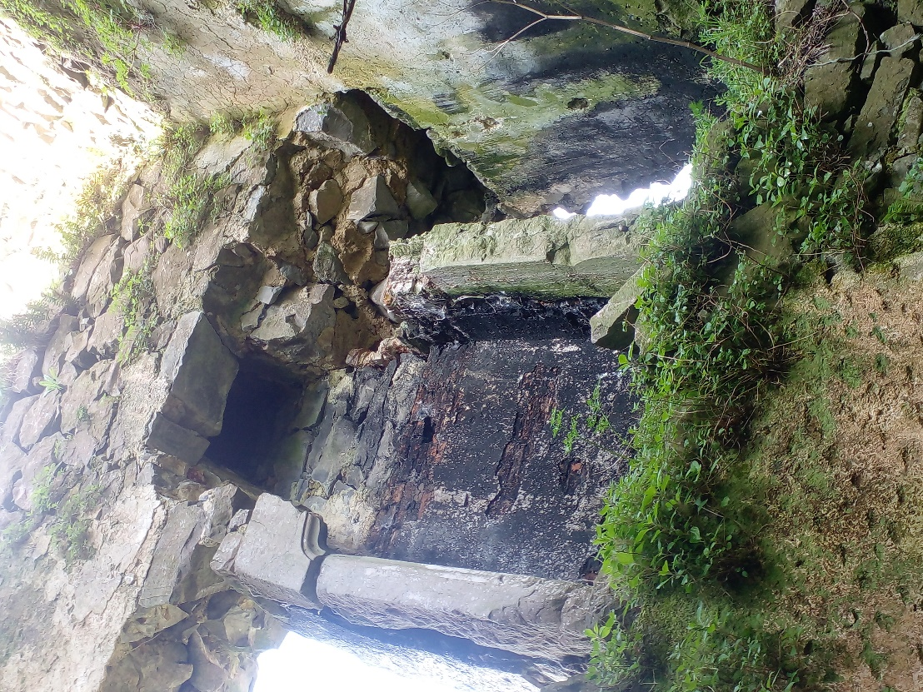

Image 1. Example of a site occupied by Barn Owl in County Longford.

INTRODUCTION
The Barn Owl Tyto alba is one of the most widely distributed terrestrial birds occurring on all continents except Antarctica. In Europe, Barn Owls breed in all countries with the exception of Fenno-scandia and Malta (Shawyer, 1998). Throughout their European range, Barn Owls are found in a wide variety of habitats, typically associated with lowland farmland, where they specialise on small mammal species (Shawyer, 1998). Although Barn Owls are listed as Least Concern in Europe, their populations are declining (BirdLife International, 2021). This has also been the case in Ireland, where the Barn Owl is a Red-listed Bird of Conservation Concern in Ireland, due to extensive declines in their breeding population and range (Gilbert et al. 2021). The Breeding Bird Atlas (2007 – 2011) highlighted a breeding range decline of 39% over the 40-year period since the original Atlas of Breeding Birds in Britain and Ireland (1968 – 1972) (Sharrock, 1976; Balmer et al. 2013). The Barn Owl population declines reflect land use changes and the intensification of farming practices which have resulted in a decline in the abundance and diversity of natural vegetation and have negatively impacted wildlife associated with farmed habitats (IPBES, 2018, Fitzpatrick et al. 2007; Copland and Lusby, 2009; Gilbert et al. 2021). The changing agricultural landscape has resulted in the loss of suitable habitats for Barn Owls, including a reduction of prey-rich foraging habitat and nesting sites (Shawyer, 1998; Nagle, 2007). Alongside these land use changes and the loss of habitat, the increased use and increased toxicity of anti-coagulant rodenticides (Roos et al. 2021), and the expansion of major road networks (Lusby et al. 2021a) are likely to be the main factors which have influenced the declines in the Barn Owl breeding range and numbers observed over recent decades in Ireland (Balmer et al. 2013; Gilbert et al. 2021).

Although Barn Owl populations have declined over recent decades, there are indications that they are recovering in certain parts of their range in Ireland. This has been identified through monitoring of Barn Owl populations which have shown increases in numbers particularly in the south of the country, including many traditional nest sites, which have not been used in many years, being occupied once again and a significant increase in the uptake of artificial nest boxes (Lusby et al. 2021b). Alongside these positive indications of a population recovery, there has been a significant focus on addressing the factors which are known to impact Barn Owl populations. These include the implementation of survey and mitigation standards for national road projects to reduce the extent of mortality on roads (Lusby et al. 2021a) and improving awareness and standards regarding the use of rodenticides to limit the effects of secondary poisoning (www.curru.ie). The provision of nest boxes for Barn Owls and protecting known nest sites have also been successful conservation measures in recent years. The Agri-Climate Rural Environment Scheme (ACRES) includes a Barn Owl specific measure which requires the installation of a nest box in a suitable location alongside implementing an integrated pest management approach to rodent control which is available to farmers in this scheme (https://www.gov.ie/en/service/f5a48-agri-climate-rural-environment- scheme-acres/). In addition to these conservation initiatives to help Barn Owl populations, there have also been significant changes in the Irish landscape which can affect Barn Owls and other predatory species, most notably the introduction and subsequent range expansion of introduced small mammal species (primarily the Bank Vole Myodes glareolus and Greater White-toothed Shrew Crocidura russula, and more recently the Field Vole Microtus agrestis) (Tosh et al. 2008; McDevitt et al. 2014). It is important to identify any changes in Barn Owl population and breeding trends and to understand and respond to the drivers of these population changes. This information, in addition to determining the effectiveness of applied conservation measures, will help to inform and direct future conservation strategies to benefit Barn Owls and the ecosystems on which they depend.

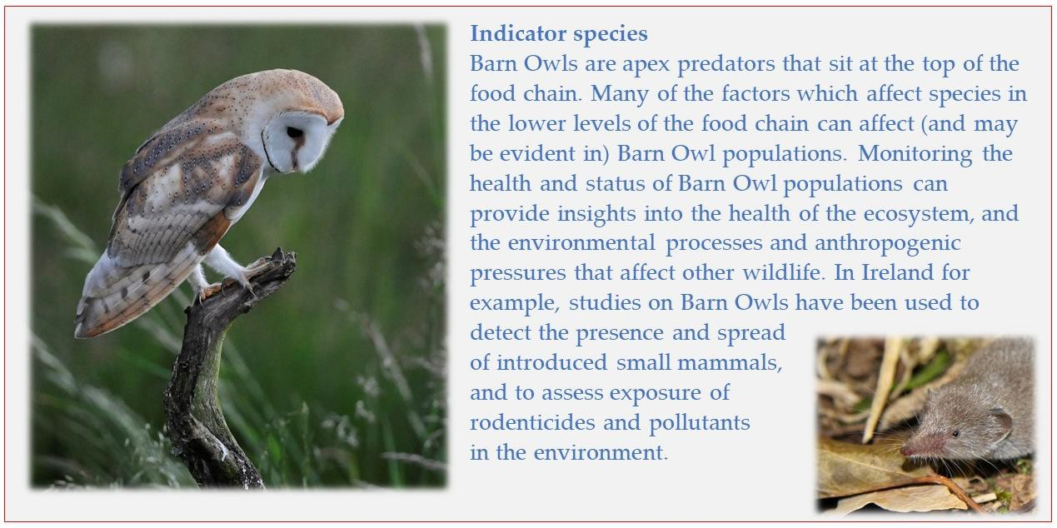
1.1 Barn Owls in County Longford
Historical data on the Barn Owl population in County Longford is very limited. There has been no specific survey or monitoring of the species in the county prior to 2024. Historical information on Barn Owl in Longford is limited to the three Breeding Bird Atlases which give an overview of population and range changes over the past 50 years. The first Atlas of Breeding Birds in Britain and Ireland (1968- 1972) showed that Barn Owls were widely, though sparsely distributed throughout County Longford, with confirmed breeding recorded in 7 of 22 (32%) 10km squares in County Longford, with their presence (confirmed breeding, probable breeding and birds seen) recorded in 11 10km squares (50%) (Sharrock, 1976). Barn Owl populations declined throughout the country from the 1960s, and this was the case in County Longford, with a very significant decline in their range recorded by the New Atlas of Breeding Birds in Britain and Ireland (1988 – 1991), which recorded only probable breeding of Barn Owl in just one (5%) 10km square (Gibbons et al. 1993), which represents a range decline of 91% over the twenty-year period since the first Atlas of Breeding Birds in Britain and Ireland (1968-1972). An increase in their range was recorded by the Bird Atlas (2007-2011), with confirmed and probable breeding recorded in six 10km squares, showing a range increase from 5% to 27% from 1988-1991; Balmer et al. 2013. The National Biodiversity Data Centre shows that Barn Owls have been widely recorded in 10 km squares in County Longford over the past 50 years during the breeding and non-breeding season (https://maps.biodiversityireland.ie/Species/11644) (Figure 1).

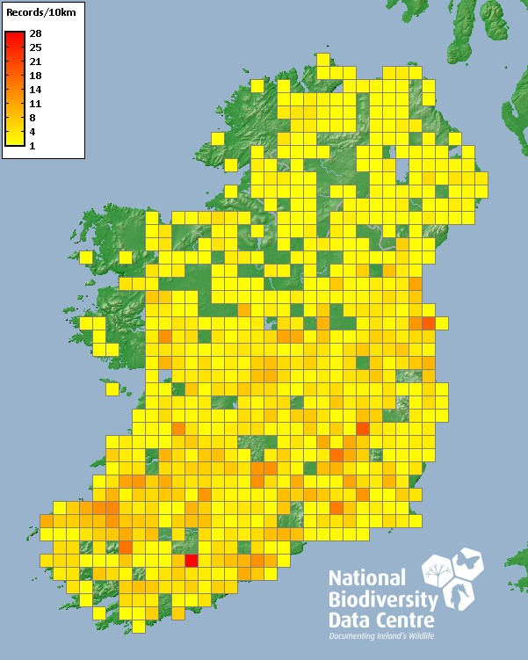

Figure 1. The distribution of Barn Owls in Ireland based on a range of sources including sightings reported to the National Biodiversity Data Centre, which shows a widespread distribution throughout County Longford during the breeding and non-breeding season. National Biodiversity Data Centre, Ireland, Barn Owl (Tyto alba).

Since the most recent Breeding Bird Atlas (2007–2011) there have been a number of changes which could potentially affect the population and range of Barn Owl in Ireland. These include the arrival and expansion of introduced small mammal species, the Greater White Toothed Shew and the Bank Vole, both of which have been recorded in neighbouring counties to Longford. There has also been an increased focus on the provision of nest boxes through the Agri-Climate Rural Environment Scheme (ACRES). The Barn Owl population in Ireland has been increasing in range and numbers in recent years and is showing positive signs of recovering to pre decline levels. This is thought to be in response to the aforementioned introduced mammal species. Therefore, it is an appropriate time to carry out specific monitoring of Barn Owl to determine the current health and trends of the Barn Owl Population and their specific conservation requirements in County Longford.
1.2 Objectives
The Barn Owl survey aims to generate information on Barn Owl populations to assess their status, trends and breeding performance in County Longford, to assess the effectiveness of existing conservation measures and to inform the conservation requirements of Barn Owl populations. To determine the status of Barn Owl populations in Longford, the survey aimed to collect new data on Barn Owls, to determine their distribution and abundance and to compare with existing datasets to assess changes in breeding range, breeding densities and nest site availability. Specifically, the Barn Owl survey aims to:
  - Determine the distribution and abundance of Barn Owls in County Longford
  - Determine the breeding range of Barn Owls in County Longford and changes in breeding range over time
  - Determine nest site selection and the availability of nest sites for Barn Owls in County Longford
  - Identify the effectiveness of existing conservation measures and make recommendations for future conservation actions to benefit Barn Owls
  - Promote the value of Barn Owls as an indicator species, to understand environmental pressures and threats

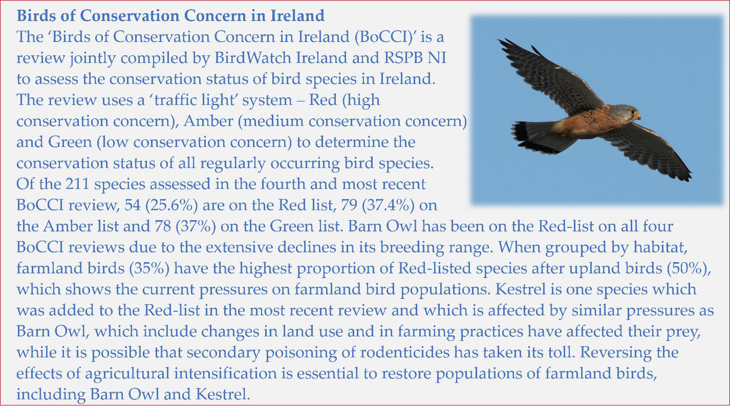

SURVEY DESIGN
The survey is designed to generate information on Barn Owl populations to assess their status, trends and breeding performance in County Longford. We did not attempt to conduct a complete census of Barn Owls in the County (i.e., to identify all Barn Owl nest sites in County Longford) as this would require extensive survey resources due to the widespread distribution of the population and the wide range of nest sites used by the species. The survey is designed to maximize the use of information available on Barn Owl populations in the region through previous species-specific and general surveys, to allow for comparisons to determine population trends and changes over time. Two approaches were employed to obtain information on Barn Owls throughout County Longford to ensure extensive survey coverage over the county and to take advantage of the potential to gather information on the species using citizen science techniques. These two approaches, as defined below, included assessing occupancy and suitability for Barn Owls at selected built structures throughout the county and initiating a citizen science survey to gather information on Barn Owl breeding sites and sightings to assess distribution and nest site selection. These methods combined were used to confirm Barn Owl sites throughout the county and to provide data to inform the specific objectives of the study, including occupancy, nest site selection and breeding performance of Barn Owls.
2.1 Survey area
The Barn Owl survey was undertaken throughout County Longford. To assess Barn Owl breeding range and changes in breeding range over time, Barn Owl occupancy and breeding status were determined in each 10 x 10 km grid square on the Irish National Grid in County Longford (hereafter referred to as the 10km square; Figure 2). This facilitated direct comparisons with the Barn Owl breeding range as defined by the Breeding Atlases which assessed Barn Owl distribution according to the 10km square grid.

Figure 2. The Barn Owl survey area which included all 10km squares throughout County Longford.
3. METHODS

3.1 Barn Owl survey
We employed two approaches to obtain information on Barn Owls and to identify occupied sites to allow us to address the specific objectives of this study. These approaches are outlined below.

Assessing Barn Owl occupancy in suitable structures
Assessing Barn Owl occupancy in suitable structures provides a reliable indication of the distribution and abundance of Barn Owls in an area, and also provides information on nest site availability. Large stone structures are important breeding sites for Barn Owl in Ireland (Sullivan & Lusby 2021; Lusby et al. 2021b). There are several ruined built heritage structures which have been used by Barn Owl for more than 28 years. In 2020, 39.6% of breeding Barn Owl pairs were recorded as nesting in ruined stone structures (including castles, ruined mansions, churches and workhouses). We identified a range of built structures in County Longford which provide potential nesting opportunities for Barn Owl, using a range of resources (information on built heritage sites online and Ordnance Survey maps). All sites were mapped in QGIS 3.12.3 and were prioritised for survey assessments to determine their suitability for and occupancy of Barn Owls. Evidence of other birds using these sites (including Kestrel Falco tinnunculus, Peregrine Falco peregrinus, Raven Corvus corax and Swift Apus apus was recorded including breeding evidence.

Citizen science survey
The survey methods outlined above are suited to assessing Barn Owl occupancy and to identifying Barn Owl breeding pairs using traditional nest sites and built heritage structures. However, Barn Owls also use a range of other nest sites including derelict farmhouses, farm buildings, trees and artificial nest boxes, mostly located on private lands. A citizen science approach to assessing Barn Owl distribution and abundance has significant benefits, as Barn Owls have a widespread distribution but their presence in specific sites and on farmed lands is often only known locally and/or by the relevant landowners. Citizen science (i.e., requesting information from the general public) has been successfully used as a survey tool to identify Barn Owl sites (Project Barn Owl in the UK) and is particularly beneficial when combined with strategic survey methods as outlined above. To gather information on Barn Owls throughout Longford, we used an online reporting tool where information could be reported, validated and responded to efficiently. We requested information on Barn Owls (including potential nest sites and sightings) in County Longford through articles in the local press, social media, email circulars and through a talk on Barn Owl in County Longford for Biodiversity Week in May 2024 to highlight the survey, engage public interest and request sightings and information on Barn Owl in the county. All information received was validated and mapped using QGIS 3.12.3. All reliable reports of potential breeding sites were investigated to confirm the presence and breeding status of Barn Owl where this was possible and using the survey techniques described below. This survey approach provided information on the distribution of the population and provided specific information on nest site selection and breeding performance of Barn Owls.

3.2 Survey techniques
All sites identified to assess the presence of Barn Owl were inspected to determine their suitability for breeding Barn Owl and for evidence to indicate the presence of Barn Owl following the methodology for surveying for Barn Owls in Ireland as defined by BirdWatch Ireland and Transport Infrastructure Ireland (2017 & 2021).

Determining site suitability for Barn Owls
Sites were considered to be ‘potentially suitable’ if they provided suitable or potential nesting opportunities for Barn Owls such as cavities or other dry, dark and secluded spaces with a floor space greater than 30cm x 30cm (Taylor, 1994) and an access point of approximately 7cm x 7cm or greater (Barn Owl Trust, 2012), also blocked chimneys, roof spaces, wall cavities, chutes, hollow tree cavities, artificial nest boxes and any other cavities which meet these specifications. Where the suitability of a site was not possible to accurately determine but where it is suspected there may be nesting opportunities available, the site was recorded as ‘potentially suitable' and further survey effort was invested to determine Barn Owl occupancy. Sites which did not provide nesting opportunities for Barn Owls were confirmed to be ‘unsuitable’ and were excluded from further survey effort on the basis that Barn Owl would not breed in these locations. All sites classed as ‘potentially suitable’ for Barn Owls were recorded, including an accurate location (10-figure grid reference using the Irish National Grid), the site type according to specific criteria (listed below in Section 3.6) and the landowner contact details for future correspondence.

Determining the presence of Barn Owl
At all sites considered to be ‘potentially suitable’ for breeding Barn Owl, a thorough day-time inspection was carried out during May to July (on the same day as assessing the suitability of the site if possible) to record the presence of signs indicating Barn Owl occupancy, including pellets, white-wash and moulted feathers. All areas of the interior and exterior of the site which were safe and possible to access were checked, with particular attention given to the ground underneath suitable cavities and perches both inside and outside the site, and the entrance to potential nesting or roosting sites. All signs which could be attributed to Barn Owl were collected in a sealable bag and labelled with the site location and date. Collection of signs facilitates assessment of future use by conducting a follow up visit to record the presence or otherwise of fresh signs. Collecting signs also allows confirmation of the species identification should this be necessary.

If it was possible to access all areas of the site and a thorough inspection confirmed no signs to indicate the presence of Barn Owls, then the site was classed as ‘unoccupied’ and was excluded from further survey effort.

At sites where sign searching may not be effective as a stand-alone method for determining Barn Owl occupancy (e.g., where part or all of the site is inaccessible, unsafe to search, or where the nest site may be concealed), where possible a nocturnal survey was carried out to confirm Barn Owl presence or absence.

Nocturnal surveys
Nocturnal surveys were conducted at all sites where Barn Owl activity was confirmed, suspected or deemed to be possible by a day-time inspection, as well as sites which were not possible to effectively check and rule out the presence of Barn Owl based on a day-time inspection alone.

Nocturnal surveys involved observing the potentially suitable or active Barn Owl site from a selected vantage point during the period when the birds are active in order to establish occupancy and breeding status based on observations, vocalisations and/or behaviour of birds associated with the site. Nocturnal surveys were conducted during the breeding period between May and August.

Nocturnal surveys were carried out from a discrete vantage point to avoid disturbance to breeding birds. The position of the vantage point was informed by the specific characteristics of the site to ensure a good view of the site, and/or area of suspected activity, including flight paths to and from the site, and preferably so that the site/area of interest was against a light background or clear sky to aid observations.

Confirming occupancy and breeding status
Sites were recorded as ‘unsuitable’ for breeding Barn Owl if the day-time inspection confirmed that there were no nesting opportunities available.
Sites were classed as ‘potentially suitable’ if the day-time inspection recorded confirmed, suspected or possible nesting opportunities for breeding Barn Owls.

Potentially suitable sites were confirmed as ‘unoccupied’ if best practice survey methods effectively recorded no evidence of Barn Owl activity at the site. The site was recorded as ‘previously occupied’ if signs to indicate the presence of Barn Owls were confirmed, however no indication of recent use was established via follow up day-time inspections and nocturnal surveys. The site may have been used as a seasonal or temporary roost or may have been previously used as a nest site and since been abandoned.

The site was recorded as ‘active’ if Barn Owl activity was confirmed via evidence of fresh signs or confirmation of one or both adults via observation or vocalisation, but there was no indication of breeding. This could be a non-breeding site, used for roosting, or a ‘breeding site’ which may have failed prior to the survey visits.

Sites were confirmed as a ‘breeding site’ based on confirmation of; a pair present at the site by observation or vocalisation; a female attending a nest, or confirmation of pre-laying, incubation or brooding behaviour; defensive behaviour by one or both adults; confirmation of a prey delivery or if young were observed or heard.

Figure 3 below shows each step of the Barn Owl survey and the determination of the suitability and occupancy of sites surveyed.

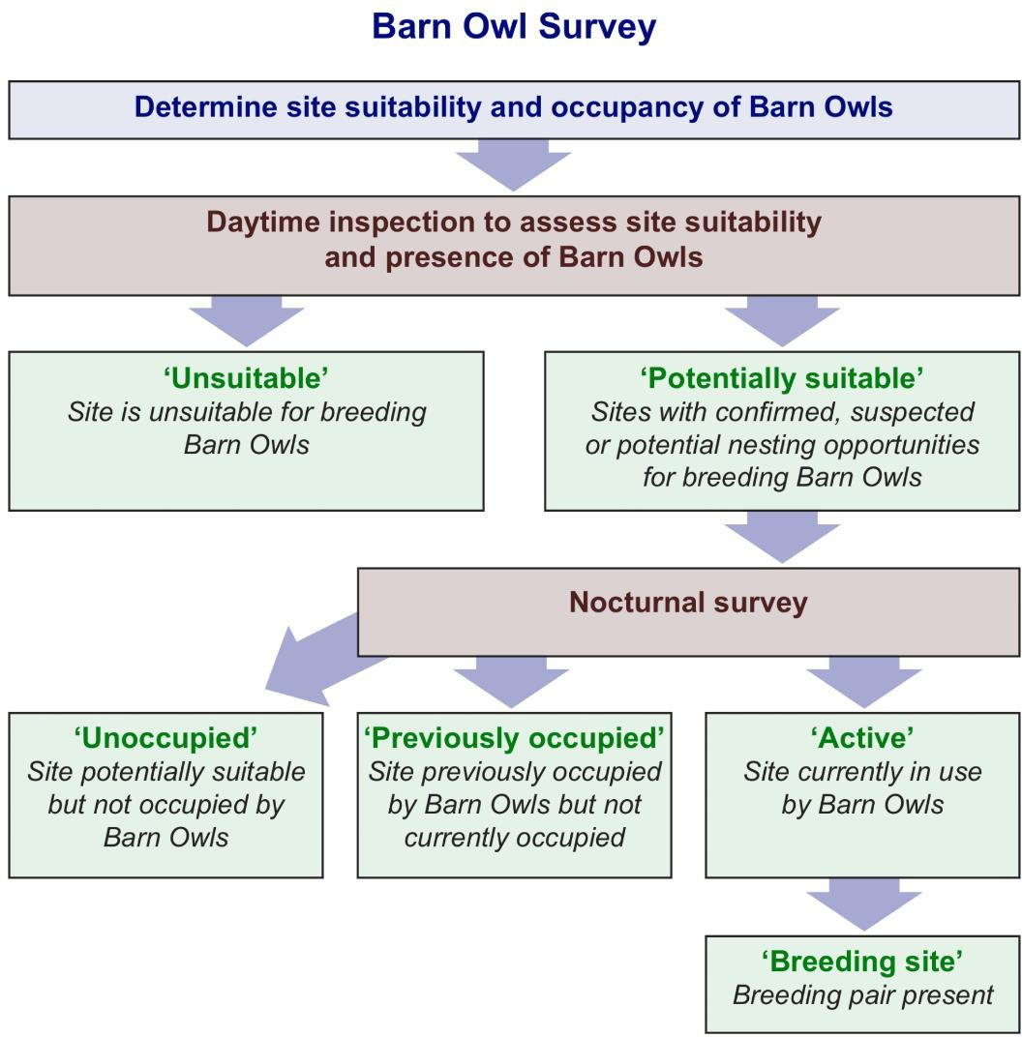

Figure 3. The steps of the Barn Owl survey to determine the suitability and occupancy of sites assessed.

3.3 Barn Owl breeding range
To define the breeding range of Barn Owls in County Longford, all sites confirmed to be occupied by Barn Owls and all sightings of Barn Owl during the breeding season 2024 (mid-March to mid-July) were mapped in QGIS 3.12.3 to visually explore the data. Each 10km x 10km square in County Longford was categorised according to the presence and status of Barn Owls within, as ‘confirmed breeding’ if one or more breeding pairs were recorded in the 10km square, ‘probable breeding/seen’ if Barn Owls were observed during the breeding season, and ‘not seen’ if there was no evidence of Barn Owl recorded in that 10km square. The highest level of breeding was used to define each square (e.g., if a square held a confirmed breeding pair and sightings of Barn Owl, then this square was classed as ‘confirmed breeding’).

To assess breeding range change over time we compared the number and distribution of 10km squares in which confirmed breeding and probable breeding of Barn Owl was recorded, to the breeding range of Barn Owl using the same metrics as defined for the Bird Atlases. To determine the long-term breeding range change we compared the current range of Barn Owls in County Longford with the range defined by the Atlas of Breeding Birds in Britain and Ireland (1968 – 1972) (Sharrock, 1976) thus providing an assessment of breeding range change over the last 50 years. To determine the medium-term breeding range change we compared the current range of Barn Owls in County Longford with the range defined by the New Atlas of Breeding Birds in Britain and Ireland (1988-1991) (Gibbons et al. 1993). This provided an assessment of the change in breeding range of Barn Owl in County Longford over the last thirty years. To determine the short- term breeding range change we compared the current range of Barn Owls in County Longford with the range defined by The Breeding Bird Atlas (2007 – 2011) (Balmer et al. 2013). This provided an assessment of the change in breeding range of Barn Owl in County Longford over the last thirteen years.
3.4 Barn Owl occupancy
To assess Barn Owl occupancy trends in County Longford, we identified 66 sites through a range of online resources, reports through the Citizen Science survey and through the identification of potentially suitable sites by surveyors during the fieldwork element of the survey to increase the number of sites assessed. There were no previous records of breeding Barn Owl sites in County Longford (National Barn Owl Database, BirdWatch Ireland). A number of sightings of Barn Owl reported to BirdWatch Ireland were investigated during the survey effort.
3.5 Barn Owl site selection
To determine Barn Owl site and nest site selection we categorised all occupied sites according to the criteria below. All sites used by Barn Owls were defined according to one of four categories which include the range of site types that have been used by Barn Owls in Ireland. These sites were further defined according to 13 site types to understand the specific site types selected and used by Barn Owl. Where possible the nest site location was determined for confirmed breeding attempts and defined according to ten categories.

Table 1. The sites, site types and nest site types used to define Barn Owl sites.

Site | Site type | Nest site type
Building Tree  Pole nest box Quarry | Castle Church  Derelict cottage  Derelict two-storey farmhouse Farm building  Mill  Nest box in farm building Nest box in derelict building Nest box on tree  Nest box on pole Occupied house Other building  Quarry | Belfry  Cavity (in building) Chimney  Chimney chute Ledge  Roof space  Nest box (including barrel) Hollow cavity (tree) Alcove  Water tank

To assess the availability of nest sites for Barn Owls in County Longford, we identified all sites surveyed and the proportion of these which were occupied by Barn Owl, suitable for breeding Barn Owl but not occupied and unsuitable for breeding Barn Owl. We determined the proportion of suitable sites which are suitable and available for Barn Owl which provides an indication of nest site availability. All sites were mapped in QGIS 3.12.3 to visually assess the spatial distribution of occupied and suitable but unoccupied sites in the county.
3.6 Barn Owl breeding performance
Breeding attempts were monitored, and accessible nest sites were visited under licence to collect information on Barn Owl breeding success, productivity, the timing of breeding and the condition of young. Information on mortality incidents and any relevant characteristics of the nest site which could impact breeding success were recorded.

Three measures were used to define the breeding performance of Barn Owls. The outcome of breeding attempts was determined as successful if the breeding attempt was considered or confirmed to result in one or more young fledging (based on recorded young at or close to fledging), or failed if a breeding attempt did not result in young fledging. Productivity was determined as the number of young at or close to fledging for all breeding attempts, and fledging success was determined as the number of young at or close to fledging for successful breeding attempts.

RESULTS
4.1 Barn Owl survey

We surveyed 53 sites of the 66 identified and confirmed five occupied Barn Owl sites in County Longford in 2024, of which two were confirmed as breeding sites. None of the occupied sites were known to be occupied by Barn Owls prior to the current survey. Three of these sites were reported through the citizen science survey by members of the public and two sites were confirmed via strategic survey efforts which involved checking suitable built structures in the county. A total of 36 sites that were deemed suitable or potentially suitable for Barn Owls were surveyed where no signs of use by Barn Owls were found. We were unable to effectively determine Barn Owl occupancy status at ten sites due to difficulties with access and locating landowners. We received six reports (sightings) of Barn Owl during the breeding season in County Longford. The distribution and abundance of Barn Owl nest sites according to the 10km square grid in County Longford is shown below (Figure 4).

Figure 4. The distribution and abundance of occupied Barn Owl sites (n = 5) in County Longford per 10km square in 2024.

4.2 Barn Owl breeding range
Barn Owls were recorded in eight (36%) of the 22 10km squares in or including the border of County Longford during the 2024 breeding season. Confirmed breeding was recorded in five 10km square (23% of 10km squares that include County Longford). The distribution of Barn Owls in County Longford according to breeding status in each 10km square is shown below (Figure 5).

Figure 5. The breeding range of Barn Owls in County Longford according to breeding status in each 10km square in 2024.

A comparison of the current confirmed Barn Owl breeding range to the breeding range as defined by the first Breeding Atlas (1968-1972) shows a decrease in breeding range of 29% over the 50-year period (Figure 6; Sharrock, 1976). Confirmed and probable breeding was recorded in 11 10km squares during the first Breeding Atlas compared to confirmed and probable breeding in eight 10km squares during 2024, representing a 27% decrease.

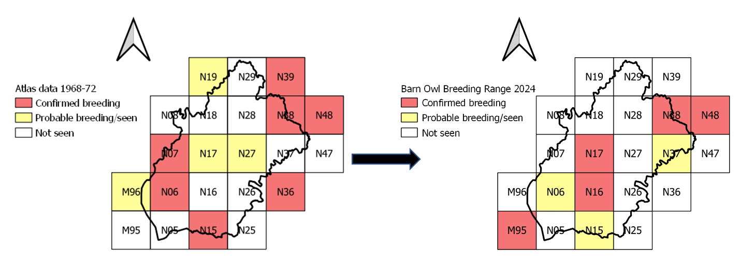
Figure 6. The breeding range of Barn Owls in County Longford recorded by the first Atlas of Breeding Birds in Britain and Ireland (1968-1972) (left) compared to the current distribution recorded by this survey (right).

A comparison of the current confirmed Barn Owl breeding range to that as defined by the New Atlas of Breeding Birds in Britain and Ireland (1988-1991) shows an increase of 500% over this thirty-year period (Figure 7; Gibbons et al. 1993). Confirmed and probable breeding was recorded in just one 10km square during the New Atlas of Breeding Birds in Britain and Ireland (1988-1991) compared to confirmed and probable breeding in eight 10km squares in 2024, representing an increase of 700%.

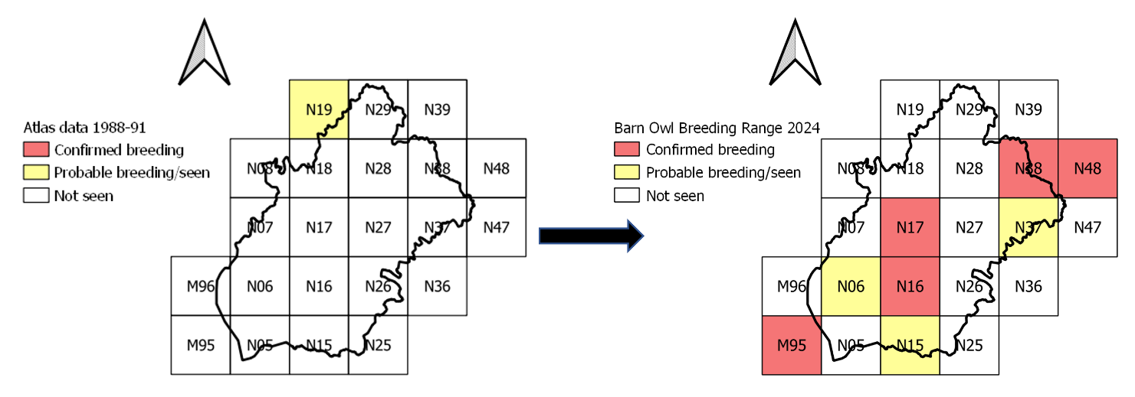
Figure 7. The breeding range of Barn Owls in County Longford recorded by the New Atlas of Breeding Birds in Britain and Ireland (1988-91) (left) showing the change in breeding range to the current distribution recorded by this study (right).

The short-term confirmed breeding range change indicates an increase of 150% over the past thirteen years. Confirmed and probable breeding was recorded in six 10km squares during the Bird Atlas (2007-2011) compared to eight 10km squares in 2024, representing a 33% increase (Figure 8).

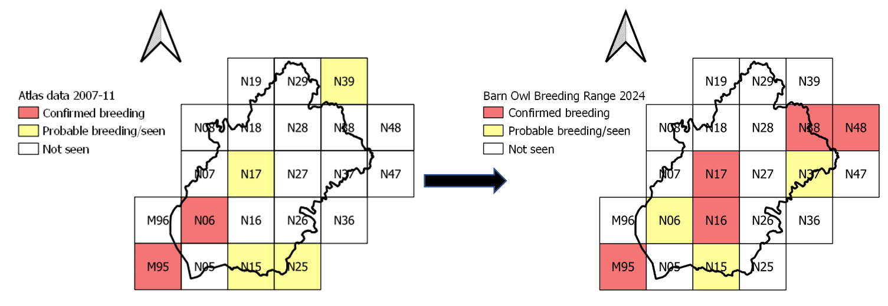
Figure 8. The breeding range of Barn Owls in County Longford recorded by the Bird Atlas (2007-2011), (left) showing the change in breeding range to the current distribution recorded by this study (right)

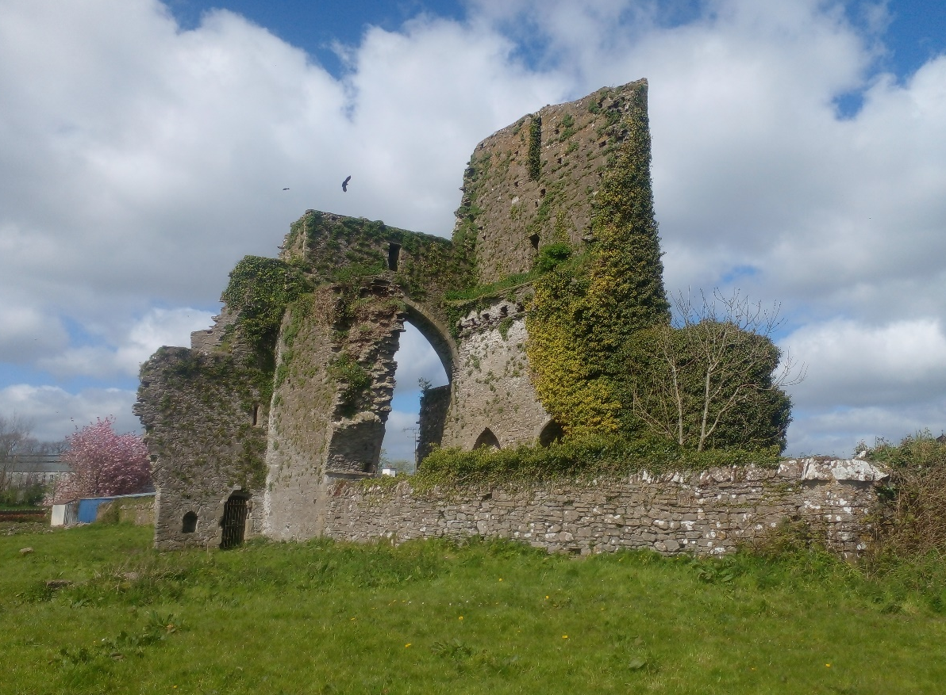

Image 2. Ruined structures such as this are incredibly important for a range of wildlife, and such buildings can support Barn Owls for many decades.

4.4 Barn Owl site selection
All sites used by Barn Owl in County Longford in 2024 were buildings. This included ruined stone structures (n = 2), a derelict house, a derelict farm yard (n = 1) and a dovecote (n = 1), see Figure 9. One further site was located with signs of previous occupancy by Barn Owl, this was located in a stone barn in the courtyard of a derelict estate. The main roost site types in County Longford were cavities (n = 2) and ledges (n = 1), however it was not possible to establish the nest site type of the only breeding site in the county due to the stage of breeding at the time of the survey visit. All nest and roost site types used by Barn Owls in County Longford in 2024 are shown in Figure 10.

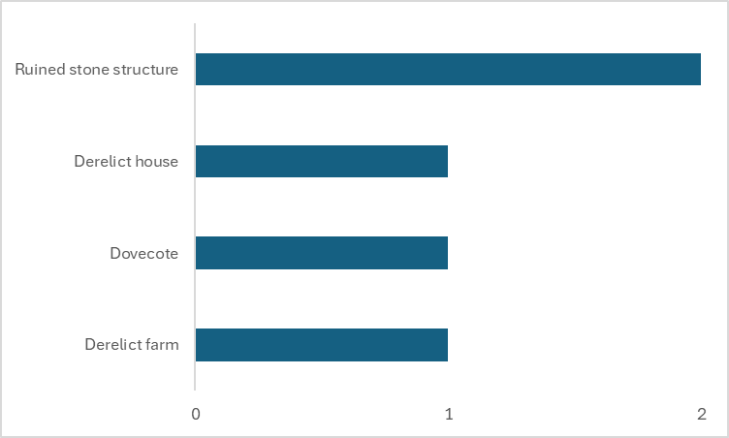

Figure 9. The range of sites used by Barn Owl in County Longford in 2024 (n = 5)

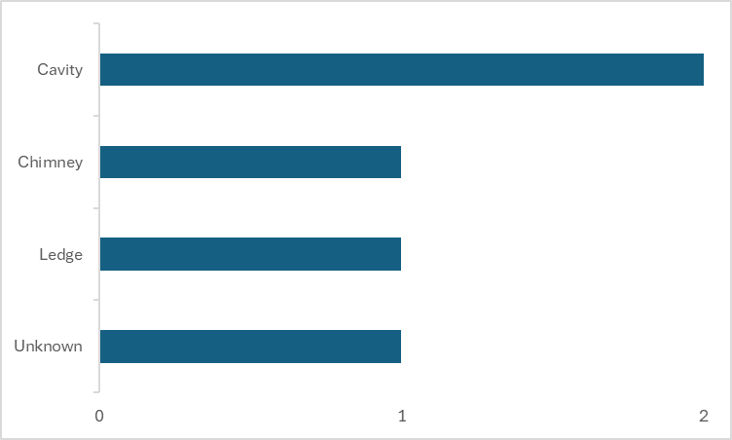

Figure 10. The range of nest and roost site types used by Barn Owl in County Longford in 2024 (n = 4)

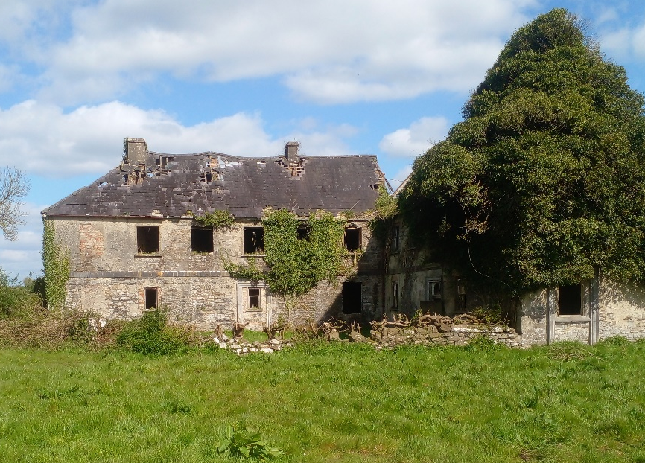
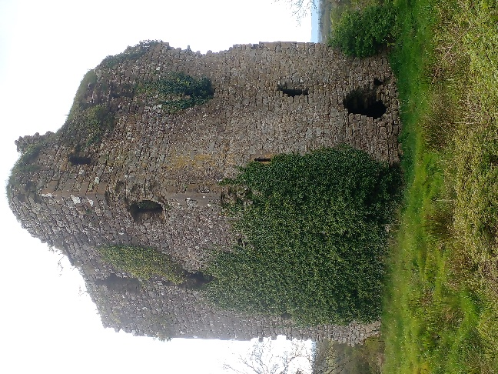
Image 3. Examples of sites which were surveyed and which were deemed to be suitable for Barn Owl in County Longford

We assessed the suitability and presence of Barn Owl in 53 sites, which included sites reported via the citizen science survey, sites where Barn Owls have previously been recorded and stone structures where there was no previous information on Barn Owl use. Of these, 41 were deemed to be “suitable” or “potentially suitable” for breeding Barn Owl. Of these 41 sites, evidence of current use by Barn Owl was found at 5 sites (12%). Old moulted Barn Owl feather fragments were found at an additional site, however given the age of the feather remains, it was determined that the site was in use by Barn Owls prior to the 2024 breeding season. Current site occupancy was not possible to determine due to the size of the site, therefore the occupancy status was categorised as “unknown” during the 2024 breeding season.

Of 53 ruined buildings surveyed, 41 sites (77%) were suitable or potentially suitable for nesting. Two (5%) of these buildings had signs of or were reported to be previously occupied by Barn Owls. Of the 41 suitable or potentially suitable sites, 5 (12%) were in use by Barn Owls, meaning that 36 or 88% of buildings surveyed were potentially suitable and available for additional Barn Owl pairs to use.

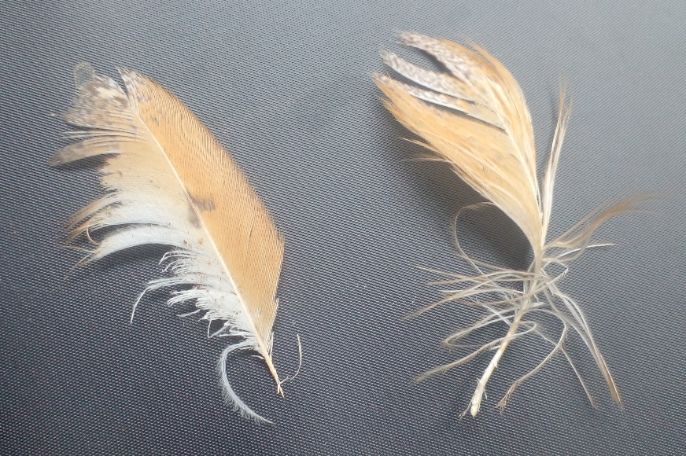

Image 4. Fragments of moulted Barn Owl feathers found at a site in County Longford in 2024.

The importance of buildings for other bird species
A number of other species of note were recorded at the sites which were surveyed. Kestrel were present in two sites, Raven in three sites, Peregrine in one site and Swift were recorded in two sites. Of the two sites occupied by Kestrel, one was also occupied by Barn Owl. Two sites occupied by Barn Owl were also occupied by Raven. And one site which was occupied by Barn Owl was also occupied by Swift.
4.5 Barn Owl breeding performance
Barn Owl breeding was confirmed at two sites in County Longford in 2024, with both breeding pairs each fledging two young.

DISCUSSION
The survey was designed to identify Barn Owl sites to assess their distribution and abundance in County Longford, and to maximise the use of existing datasets on the species. Two different approaches were employed to identify Barn Owl sites, and the benefits of adopting these approaches is shown by the fact that Barn Owl sites were identified using both survey techniques. In particular, the citizen science survey technique used through this survey proved beneficial, given the only confirmed nest sites were found as a result of reports from members of the public. Incorporating a citizen science element also facilitated increased coverage over the county in addition to providing other benefits such as increased engagement and participation in the survey and awareness of the species and its conservation requirements. As part of this, a public talk was given during Biodiversity Week in Longford Town at the beginning of the survey.

The citizen science survey techniques complemented the other survey techniques, and it would not have been possible to rely on the citizen science survey alone, which would not have provided the same number of Barn Owl sites or information on nest site availability as required. The citizen science survey required data validation, as several reports of ‘Barn Owl’ were received which related to other species, thus highlighting the need to confirm information received. The use of an online survey tool also improved the efficiency of reporting and receiving the information and performing validation. It is clear from our findings that citizen science techniques can form an important element of Barn Owl surveys if structured appropriately and the limitations are recognised. Citizen science surveys should include validation of information received and should be accompanied by strategic survey methods, as we employed in the current study. This survey was also designed to maximise the use of existing datasets on Barn Owl and specifically information on the species in County Longford. This approach had significant merit, and allowed trends in numbers, occupancy and range to be determined through comparisons with existing datasets. This shows the value of recording data in a standardised way and in making the data available for the purposes of future studies and comparisons.

Assessments of the status of Barn Owl populations in Ireland have been primarily informed by observed changes in breeding range over time (Article 12 reporting; Gilbert et al. 2021). It is important to recognise the potential for bias in the comparisons which inform estimates of breeding range change, which can be influenced by variation in observer effort between surveys. In all cases, and particularly for multi-species surveys, such as the Bird Atlases, the recorded breeding range should be considered to be an underestimate of the true breeding range, as it is unlikely that all breeding pairs or occupied sites will be identified. This is also the case with the current survey, which did not employ a comprehensive census to identify all Barn Owl sites throughout the county. Nevertheless, provided that the survey effort invested and the survey methods employed allow for comparisons, then changes in breeding range can be inferred and this has been a widely used method to track Barn Owl range changes over time (Article 12 reporting Gilbert et al. 2021).
After severe declines in range between the 1960s and the 1980s (91% decline in range, from 11 to one 10km square), the Barn Owl range in Longford had increased by the latest county-wide population assessment in 2007-11 (500% increase, from one to six 10km squares), though it was still severely restricted compared to the breeding range recorded in the 1960s (Sharrock, 1976; Gibbons et al., 1993; Balmer et al. 2013). The findings of the current survey show that Barn Owl range in Longford has increased further since the 2007-11 Atlas survey (33% increase, from six to eight 10km squares), and are now present in a minimum of 36% of 10km squares in the county, albeit only two nest sites were identified, in addition to three roost sites (Figure 8).

The increase in breeding season range observed during the current study has been influenced by increases in surrounding counties where invasive small mammal species are now known to occur. This includes Cavan, where the breeding season range has increased 50% over the past 13 years, with both Greater White-toothed Shrew and Field Vole, a small mammal species new to Ireland having first been discovered in Monaghan in 2020, now featuring in Barn Owl diet in Cavan (Moynagh and Viscardi, 2022; McCarthy and Lusby, in prep.). Two of the confirmed breeding squares in Longford in 2024 resulted from nest sites found in Cavan. However, in order to make accurate comparisons with previous Bird Atlases, it is crucial that Barn Owl breeding records in parts of surrounding counties that are covered by the survey counties’ 10km squares are included.

Barn Owls appear to respond positively to the presence of invasive small mammal species, as they provide additional food where food may otherwise be limited. This is demonstrated in the frequency with which these species occur in Barn Owl diet where they are present, with Greater White-toothed Shrews accounting for up to 80% of Barn Owl diet in some cases, and Bank Voles accounting for up to 60% in other cases. Where these small mammal species occur, Barn Owl population increases have also been observed. This has been well demonstrated in Munster in particular, where both the Bank Vole and Greater White-toothed Shrew were first discovered. In Cork, where both small mammals are known to have been present for around 40 and 10 years respectively, confirmed Barn Owl breeding range has increased by 132% since 2011, and 480% since the late 1980s (McCarthy et al. 2023). It can be expected that similar trends in Barn Owl numbers may follow in Longford with the arrival and establishment of the these small mammals.

While Barn Owls have been increasing in numbers in Ireland in recent years, other farmland bird species, such as Kestrel, continued to decline over the same period (Gilbert et al. 2021). The reasons behind the Barn Owl population increase appear to be strongly linked to changes in small mammal communities. Although local, small-scale actions by landowners, farmers and conservationists have created and protected some suitable Barn Owl foraging habitat, it is unlikely that this has driven Barn Owl population increases at a large scale as more suitable habitat continues to be lost rather than gained through agricultural intensification. Increasing awareness in relation to the use of rodenticides is also unlikely to have had an impact due to the local, small-scale implementation of rodenticide alternatives. The provision of nest boxes does not appear to be a common practice in Longford as only two nest boxes were located during the fieldwork and neither were occupied, and therefore does not appear to be contributing to the increase in Barn Owl range in the county. Therefore, the most likely driver of Barn Owl population increase is changing small mammal communities, however increased survey effort may also be contributing to the apparent increase in breeding range. Research is currently on-going to further our understanding of the impact of non-native small mammal species as well as nest boxes and other factors on Barn Owl populations. The information collected as part of the current study will help inform these effects. The protection of known nest sites, habitat creation and enhancement measures would deliver significant benefits for Barn Owl populations and other wildlife in Longford, which should be delivered through targeted agri-environment measures, such as that seen in the new Agri-climate Rural Environment Scheme (ACRES).

The majority of occupied Barn Owl sites were in ruined stone buildings (n = 3), with a fourth in a derelict house, while the fifth site was located on a derelict farm, with the exact nest site unknown. This shows the importance of ruined and derelict structures for Barn Owls in Longford. These sites should be protected, and if the suitability of these sites is compromised, then alternative sites should be provided in the form of nest boxes, the effectiveness of which is demonstrated by the fact that nest boxes have been shown to be the main site type occupied by Barn Owl in other counties in Ireland (McCarthy et al. 2023). The effectiveness of nest boxes as a conservation tool for Barn Owls has been demonstrated by the results of surveys in counties Cork and Cavan, as they provide a safe, secure nesting and roosting sites and in some areas they provide nest sites where nesting would otherwise not be possible.

Built structures are not only important for Barn Owl but also support a range of other species, which includes Kestrel, Peregrine, Raven and Swift. Kestrel is a recent addition to the Red-list on the Birds of Conservation Concern in Ireland (Gilbert et al. 2021), and we showed that buildings are an important nesting site for the species as they were the most common raptor recorded in buildings surveyed, behind Barn Owl.

The availability of suitable nest sites and the provision of nest boxes in suitable areas is an important consideration for Barn Owl conservation in Longford going forward. Of 53 ruined buildings surveyed, 41 sites (77%) were suitable or potentially suitable for nesting. Of these 41 sites, 5 (12%) were in use by Barn Owls, meaning that 88% of these suitable and potentially suitable buildings surveyed are available for additional Barn Owl pairs to use. In other counties in Ireland that are also experiencing an increase in Barn Owl numbers, the availability of nest sites has seemingly become a restraint on the population recovery, with 80% of suitable sites surveyed in County Offaly being occupied by Barn Owls leaving only 20% available for new breeding pairs (Lusby et al. 2022). This is to be expected with an increasing population, and particularly for Barn Owl based on their specific nesting requirements. Although trees may become available to Barn Owls, most buildings which are suitable for Barn Owl are already present in the landscape and it is likely that more buildings will be lost (due to renovation or dilapidation) than become available. Based on our findings, although not an immediate priority, we recommend that a nest box scheme is put in place in the coming years to ensure that the availability of nest sites does not limit the population recovery, particularly in south and east of the county where there is an abundance of suitable foraging habitat for Barn Owl.

RECOMMENDATIONS
Barn Owls have increased in range and number over the last 30 years in County Longford, however they are still very limited in terms of confirmed breeding distribution within the county itself. It is important to implement measures to ensure the health of the population in the long-term and to maximise and sustain the anticipated increase in numbers of Barn Owl in the county in the years to come. We set out several recommendations to secure and improve the conservation status of Barn Owls in County Longford which are informed by the findings of this study.

  - We showed the importance of ruined stone structures for Barn Owl and other bird species. Due to the importance of built heritage structures and other large, ruined structures for Barn Owl, it is important that existing nest and roosting sites are appropriately protected, to ensure they remain suitable.

  - This study showed the benefits of collecting data on Barn Owl populations over time, and we recommend that monitoring of selected sites is continued on an annual basis, in order to track future changes in local Barn Owl populations, as well as assessing the effectiveness of conservation measures applied and informing direct and site-specific conservation requirements.

  - Conservation measures for Barn Owls are most effective when they are targeted to the areas where they are required and to address the issues which affect local populations. The data generated through this study can be used to direct such conservation efforts and we recommend the development of a landscape suitability map for Barn Owl for County Longford to identify the areas which are suitable for the species and where conservation measures should be focused.

  - The application and effectiveness of the Barn Owl nest box measure in ACRES should be
assessed to determine its benefits to Barn Owls in Longford.

  - Research on the response of Barn Owls to habitat provision and improvement measures (such as Wild Bird Cover) is important, as is developing a better understanding of the risks and impacts to the species associated with the use of rodenticides.

  - The spread of the Greater White-toothed Shrew, Bank Vole and Field Vole should be monitored in Longford over the coming years through the analysis of Barn Owl pellets, in order to get an understanding of their ranges’ as well as the impact they are having on Barn Owl diet in the county.

  - Research efforts should focus on developing a better understanding of the effects of different small mammal species compositions on Barn Owl diet, foraging success, prey delivery patterns, and breeding success.

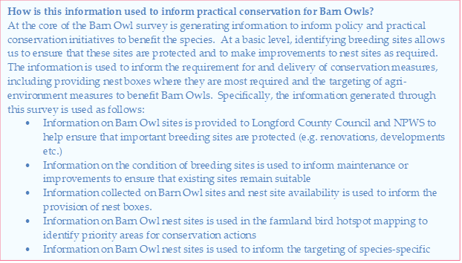

REFERENCES

Balmer, D., Gillings, S., Caffrey, B., Swan, B., Downie, I. & Fuller, R. (2013). Bird Atlas 2007-11. The breeding and wintering birds of Britain and Ireland. British Trust for Ornithology, Thetford.

Barn Owl Trust (2012). Barn Owl Conservation Handbook, Pelagic Publishing, Exeter.

BirdLife International (2021). European Red List of Birds. Luxembourg: Publications Office of the European Union.

Cooke, D., Nagle, A., Smiddy, P., Fairley, J. & Ó Muircheartaigh, I. (1996). The diet of the Barn Owl Tyto alba in County Cork in relation to land use. Biology and Environment: Proceedings of the Royal Irish Academy, 96B (2), 97-111.

Copland, A. & Lusby, J. (2009). Lowland Farmland. In: R. Nairn & J. O’Halloran, eds. Bird Habitats in Ireland. 124-137. The Collins Press, Cork.

Fitzpatrick, U., Murray, T. E., Paxton, R. J., Breen, J., Cotton, D., Santorum, V. & Brown, M. J. F. (2007). Rarity and decline in bumblebees – A test of causes and correlates in the Irish fauna. Biological Conservation, 136(2): 185-194.

Gibbons, D.W., Reid, J.B. & Chapman, R.A. (1993). The New Atlas of Breeding Birds in Britain and Ireland: 1988–1991. T. & A.D. Poyser, London.

Gilbert, G., Stanbury, A. & Lewis, L. (2021). Birds of Conservation Concern in Ireland 2020 – 2026.
Irish Birds, 9: 523—544.

IPBES (2018). The IPBES assessment report on land degradation and restoration. Montanarella, L., Scholes, R., and Brainich, A. (eds.). Secretariat of the Intergovernmental Science-Policy Platform on Biodiversity and Ecosystem Services, Bonn, Germany.
Lusby, J., Watson, D. & Nagle, T. (2010). Cork Barn Owl Research Project 2010 Report. BirdWatch Ireland, Wicklow.

Lusby, J., O’Clery, M., McGuinness, S., Tosh, D. & Crowe, O. (2021a). The interactions between Barn Owls and major roads: informing management and mitigation. TII Publications reference RE- ENV07004.

Lusby, J., McCarthy, A., O’Clery, M., Lynch, Á., Bayley, S., Nagle, T., Forkan, C., Stanley, M. & Nolan,
B. (2021b). Barn Owl Monitoring Report 2020. BirdWatch Ireland, Wicklow.

Lusby, J., Purcell, D. & Franks, D. (2022). Barn owl population status and trends in County Offaly. BirdWatch Ireland, Wicklow.

McCarthy, A., O’Donohoe, S. & Lusby, J. (2022). Barn Owl population status and trends in County
Limerick. BirdWatch Ireland, Wicklow.

McCarthy, A., Ó Teangana, D., Nagle, T., Bayley, S., Heardman, C., Rees, D., Deasy, C., Riordan, N., McDonnell, B. & Lusby, J. (2023). Barn Owl population status and trends in County Cork. BirdWatch Ireland.

McDevitt, A.D., Montgomery, W.I., Tosh, D.G., Lusby, J., Reid, N., White, T.A., McDevitt, D.C., O’Halloran, J., Searle, J.B. & Yearsley, J.M. (2014). Invading and Expanding: Range Dynamics and Ecological Consequences of the Greater White-Toothed Shrew (Crocidura russula) Invasion in Ireland. PLoS ONE 9(6).

Moynagh, J., & Viscardi, P. (2022). Vouchered record of Field Vole (Microtus agrestis) in Ireland from County Monaghan (H32). Irish Naturalists Journal, 104-105.

Nagle, T. (2004). The status of Birds of Prey and Owls in County Cork. In: C. Cronin, C. Barton, H. Hussey & M. Carmody, eds. Cork Bird Report 1996 – 2004. 285 – 308. Cork Bird Report Editorial Team.

Nagle, T. (2007). The loss of Barn Owl Tyto alba breeding and roosting sites in County Cork: A contributory factor in the species decline. Irish Birds, 8: 314-315.

O’Clery, M., McDonnell, B. & Lusby, J. (2013). Duhallow Raptor Conservation Project, Final Report 2013. James O’Keeffe Institute, Newmarket.

Roos, S., Campbell, S.T., Hartley, G., Shore R.S., Walker, L.A. & Wilson, J.D. (2021). Annual abundance of common Kestrels (Falco tinnunculus) is negatively associated with second generation anticoagulant rodenticides. Ecotoxicology, 30: 560–574.

Tosh D.G., Lusby, J., Montgomery, W.I. & O’Halloran, J. (2008). First record of greater white-toothed shrew Crocidura russula in Ireland. Mammal Review, 38: 321-326.

Sharrock, J. T. R. (1976). The Atlas of Breeding Birds in Britain and Ireland. T. & A. D. Poyser, Berkhamsted.

Shawyer, C.R. (1998). The Barn Owl. Arlequin Press, Wheathampstead.

Sullivan, I. & Lusby, J. (2021). Wildlife in Buildings: Linking our built and natural heritage. BirdWatch Ireland, Wicklow.

Taylor, I.R. (1994). Barn Owls: Predator–Prey Relationships and Their Conservation. Cambridge University Press, Cambridge.

Transport Infrastructure Ireland (2017). Barn Owl Surveying Standards for National Road Projects.
T.I.I. Publication no. RE-ENV-07005.

Transport Infrastructure Ireland (2021). Survey and Mitigation Standards for Barn Owls to inform the Planning, Construction and Operation of National Road Projects. TII Publications reference PE-ENV- 07005.

